Tour ID: 81837  
Tour Name: Iceland Circle - 8 Days

Tour destinations: ['Reykjavik', 'Grábrók Volcano', 'Akureyri', 'Myvatn', 'Mount Namaskard', 'Egilsstadir', 'Vatnajokull National Park', 'Kirkjubaejarklaustur', 'Vik', 'Reykholt']

Tour destinations images:

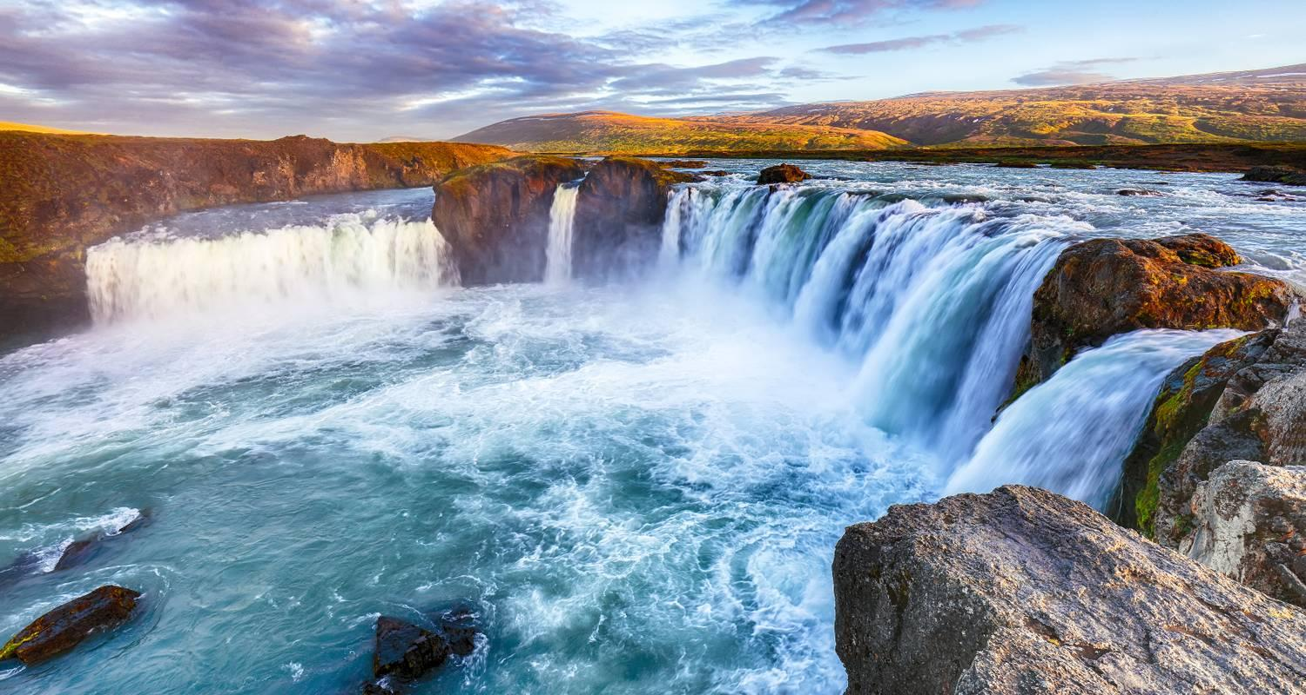

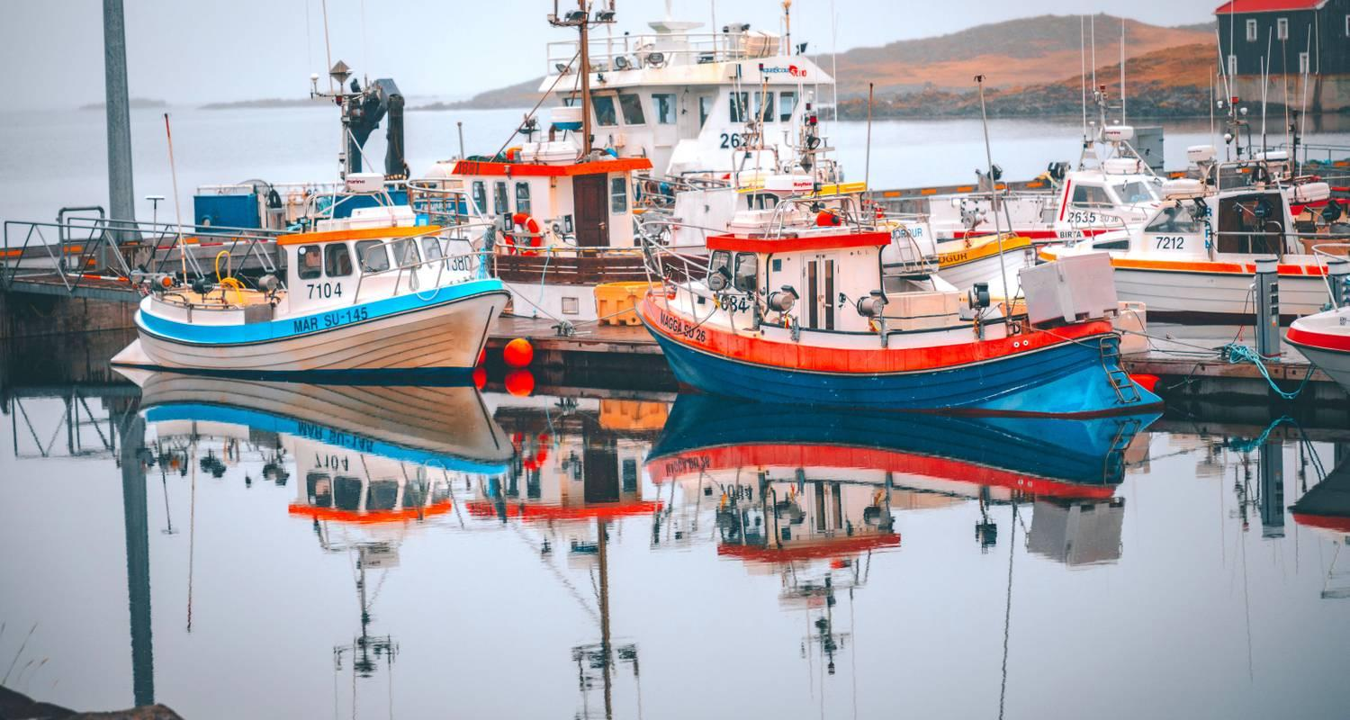

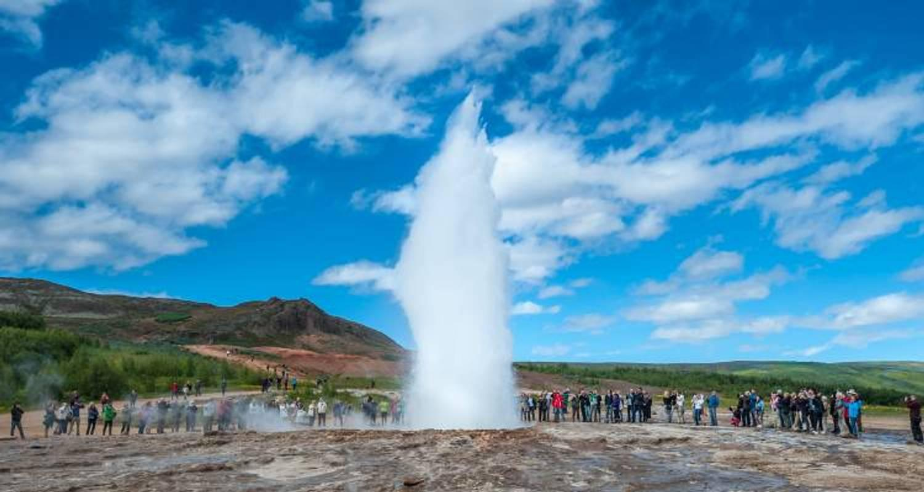

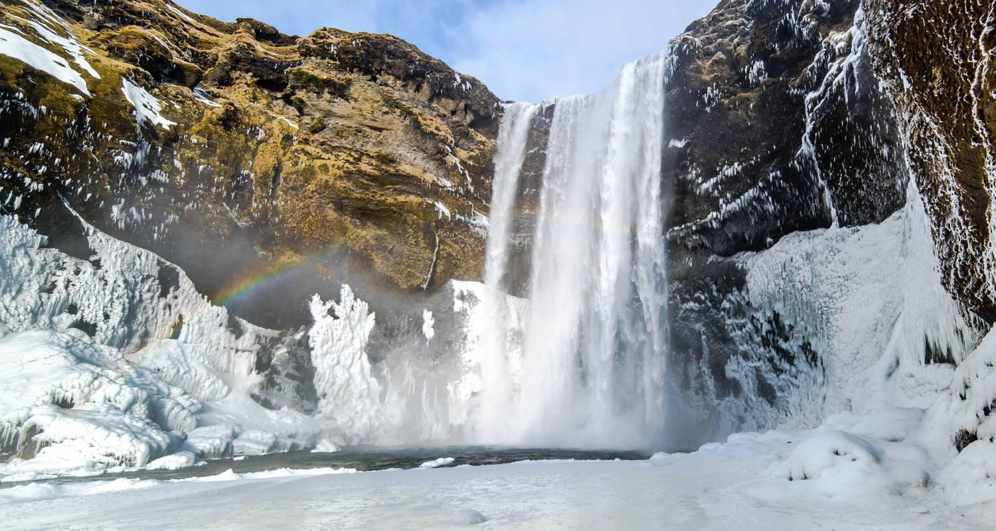

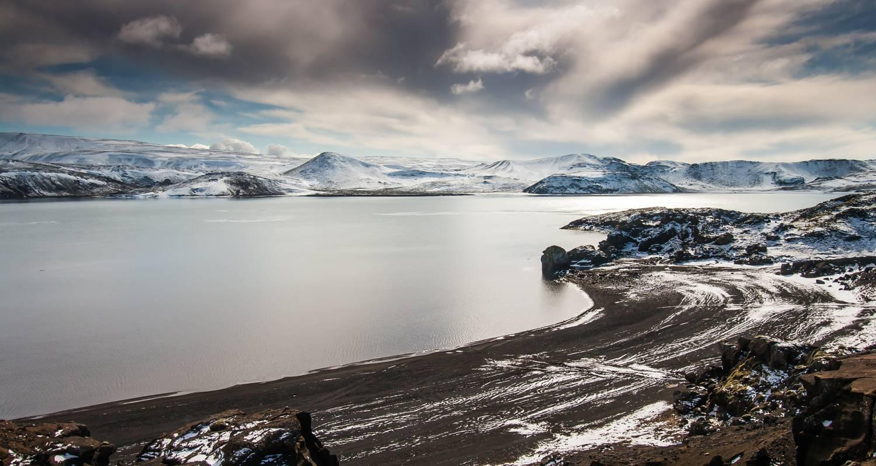

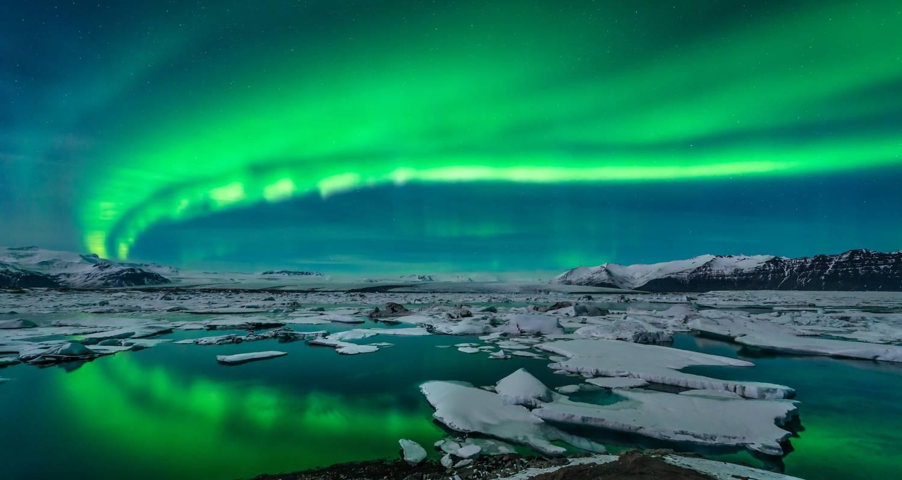

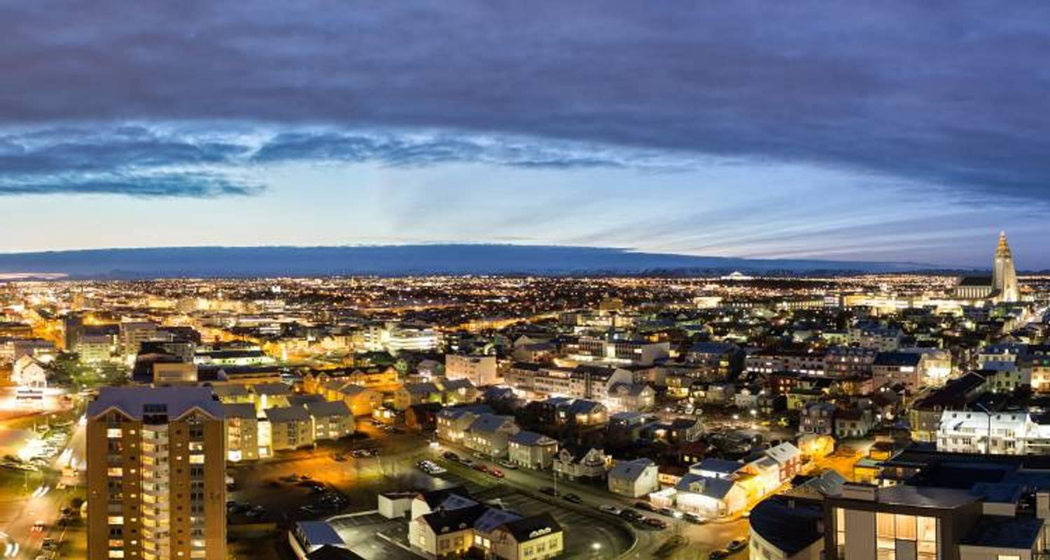

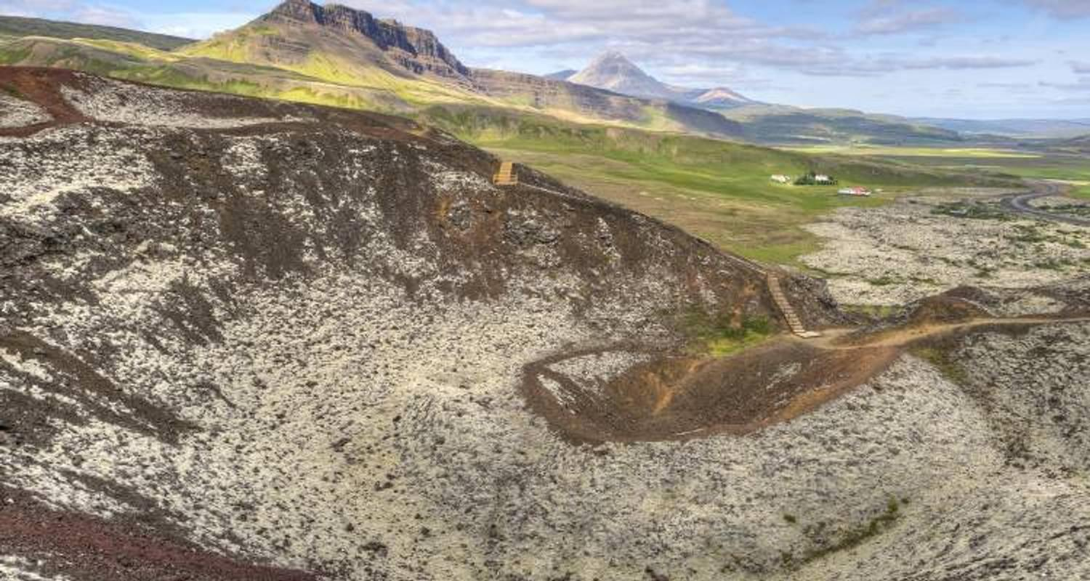

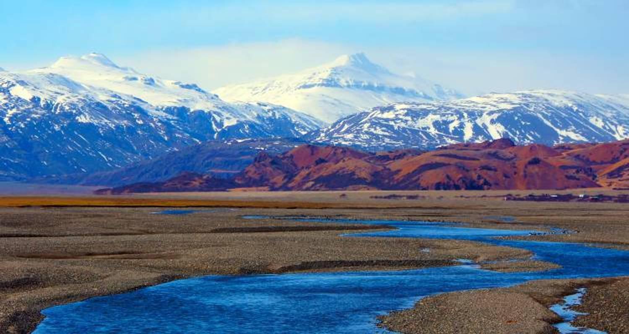

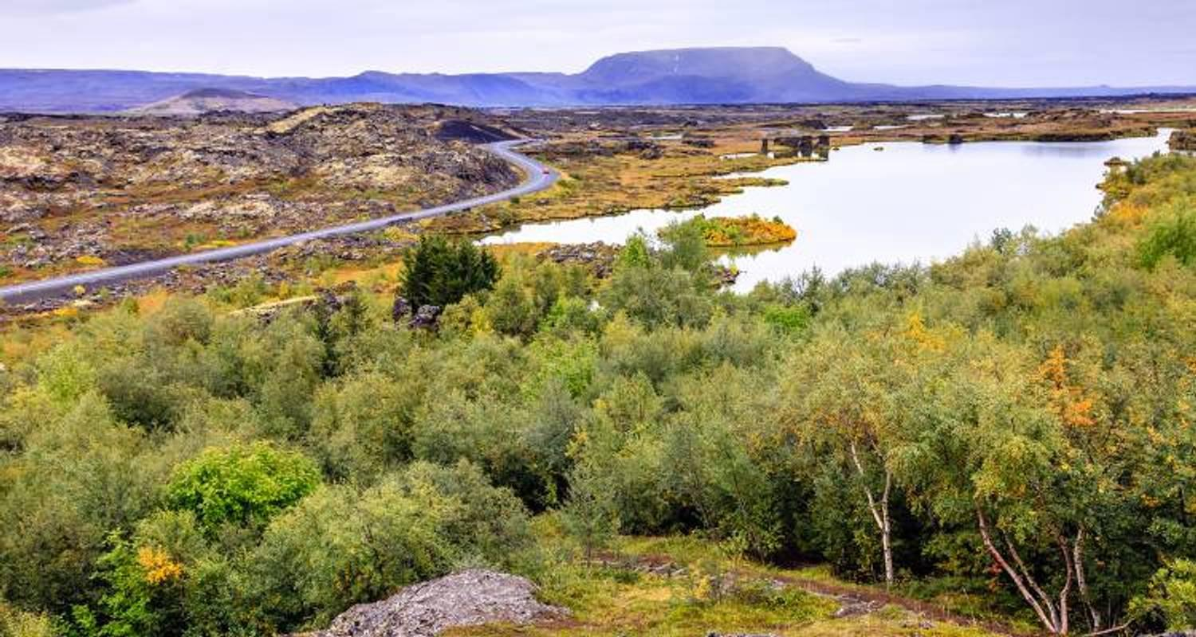

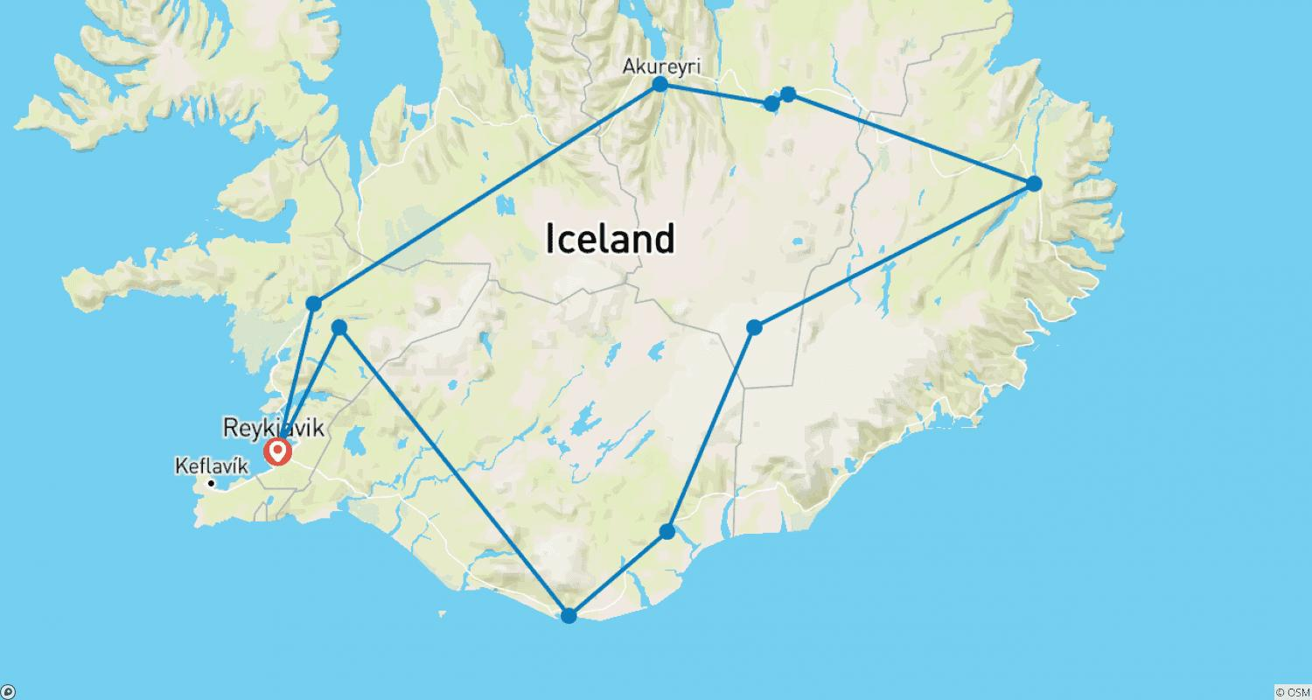

Tour ID: 82883  
Tour Name: Iceland Northern Lights & Golden Circle

Tour destinations: ['Reykjavik', 'Thingvellir National Park', 'Dover', 'Gullfoss', 'Solheimajokull', 'Skogafoss', 'Seljaland']

Tour destinations images:

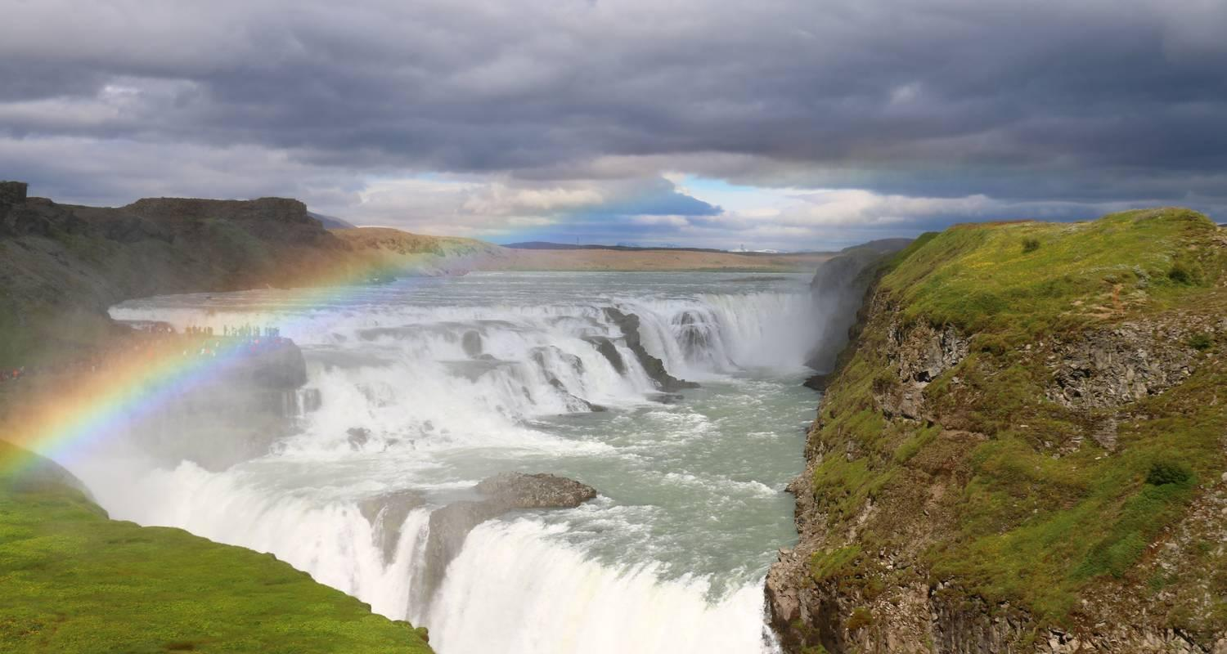

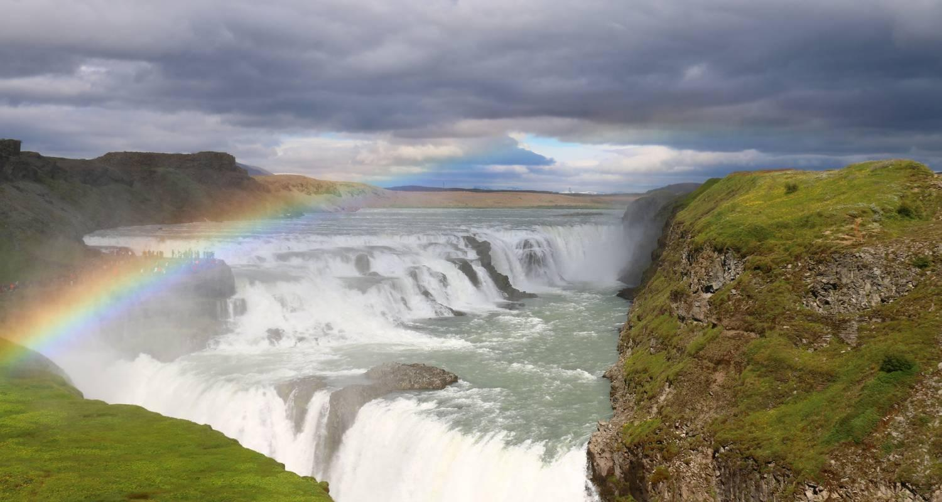

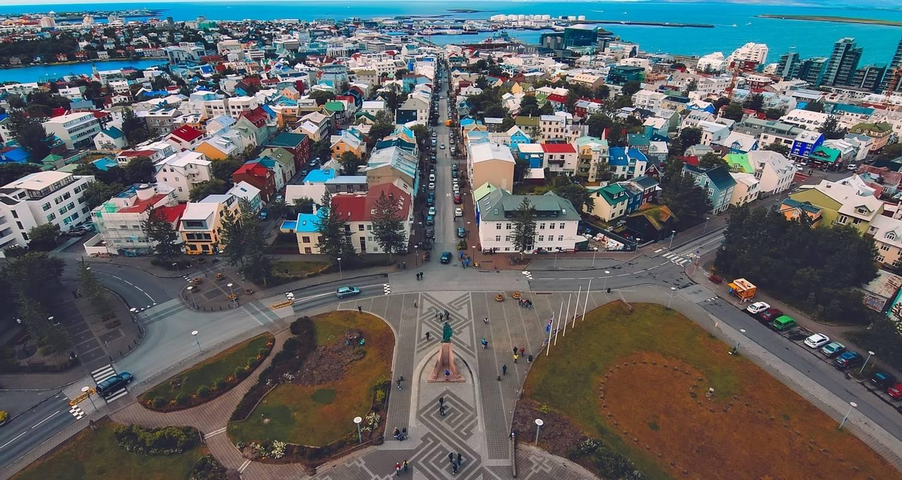

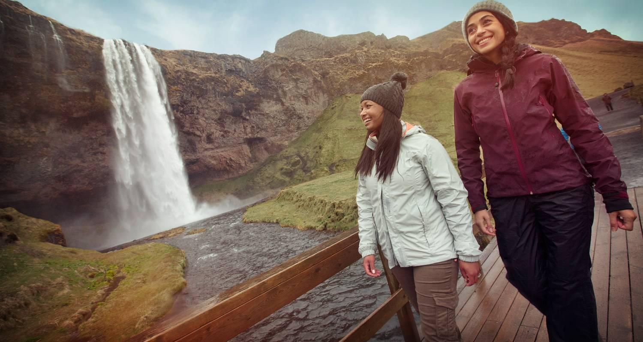

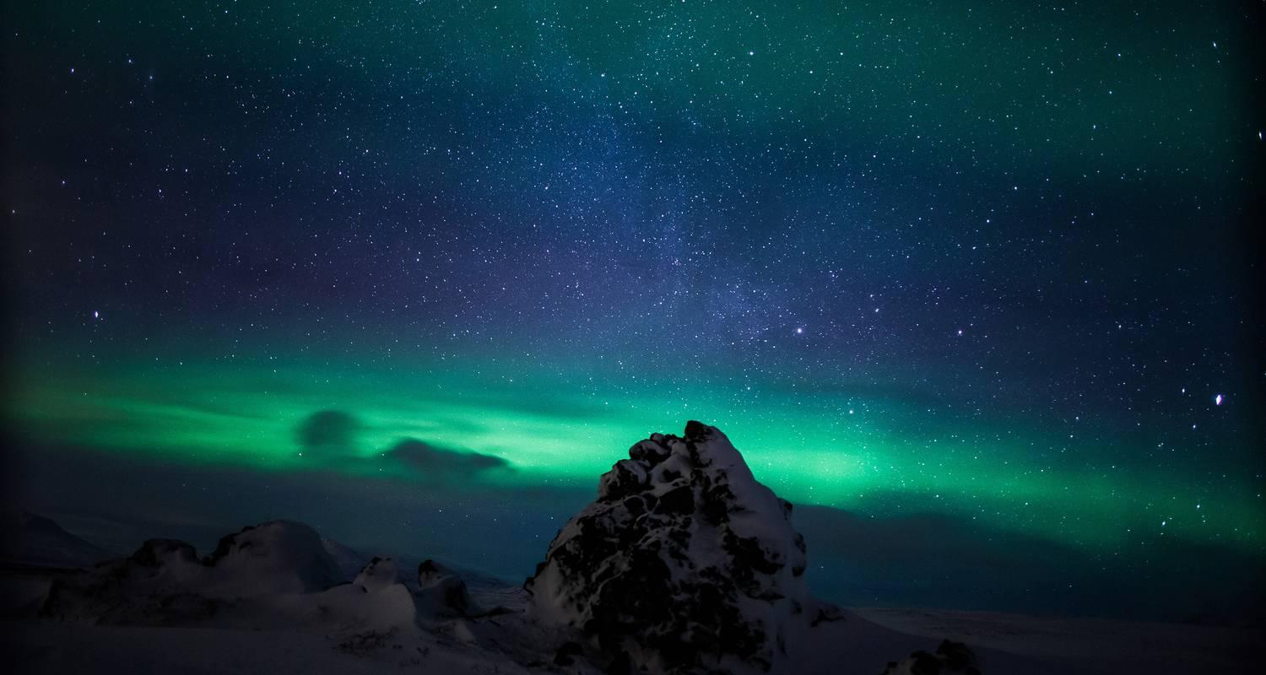

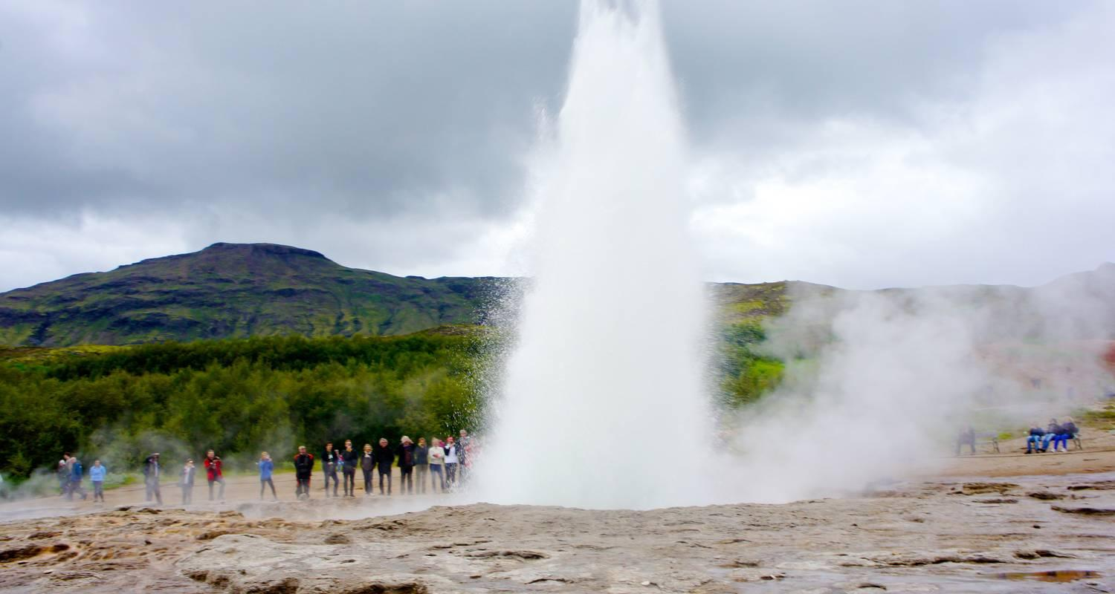

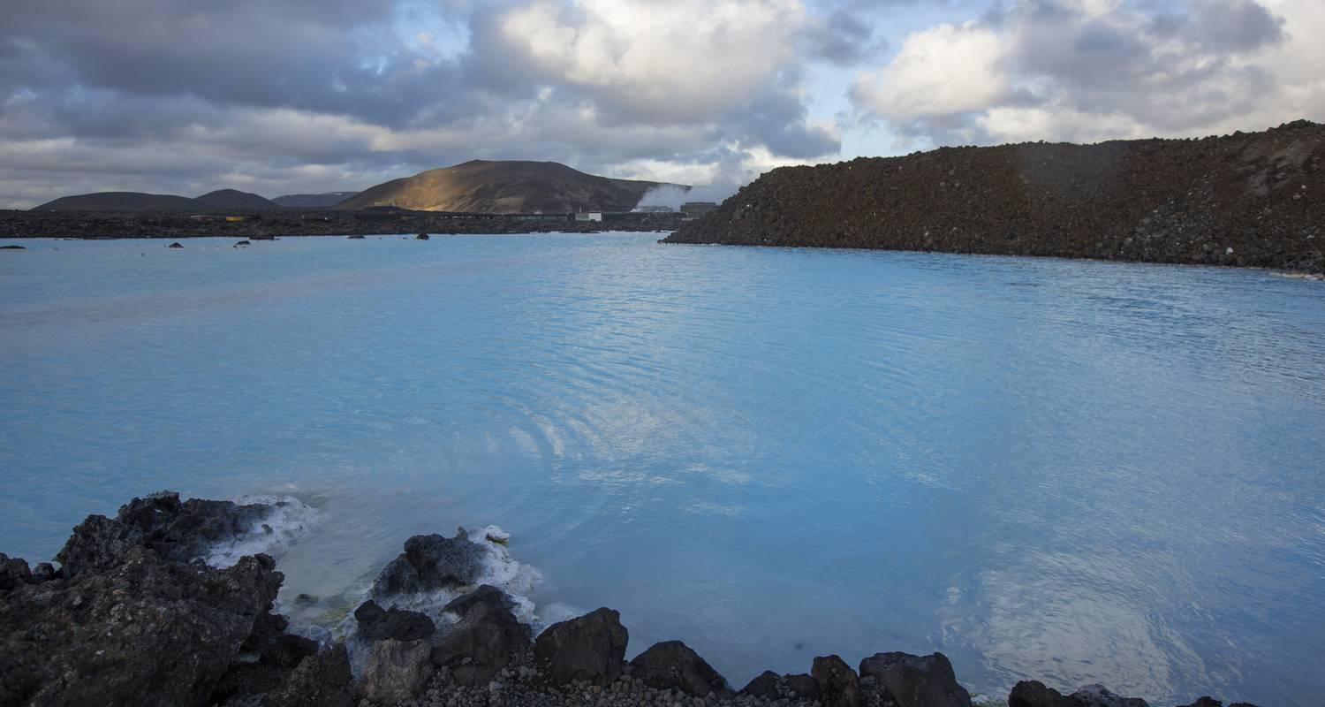

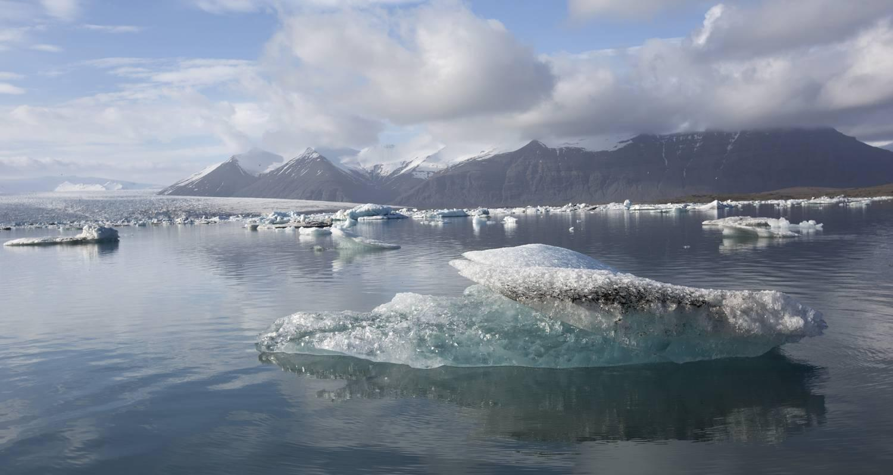

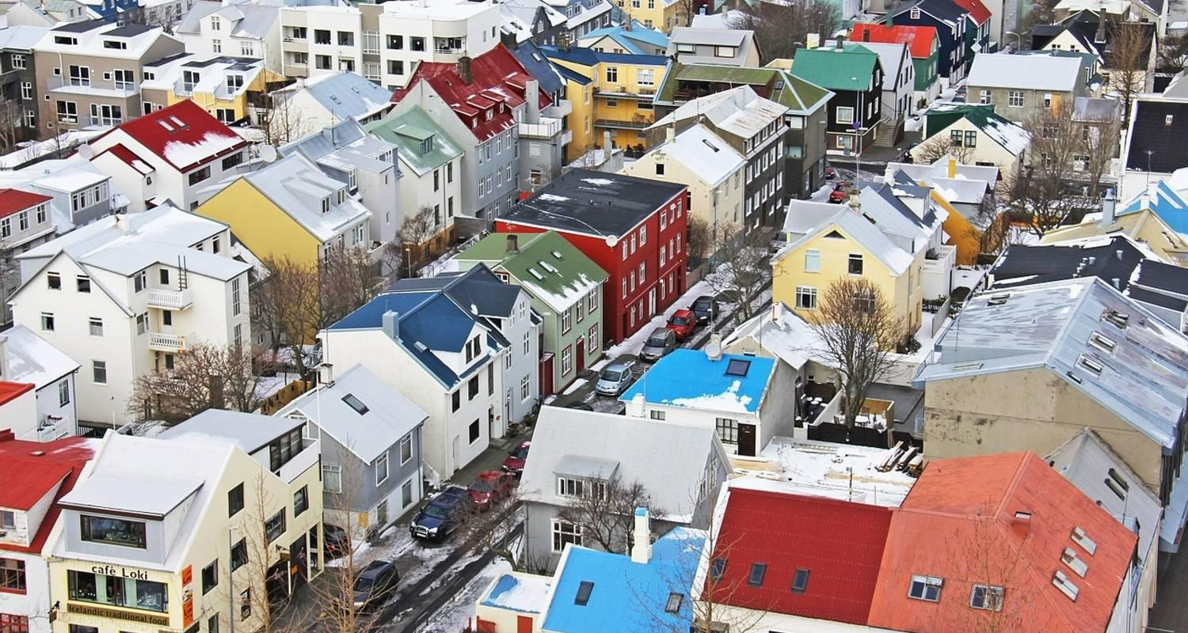

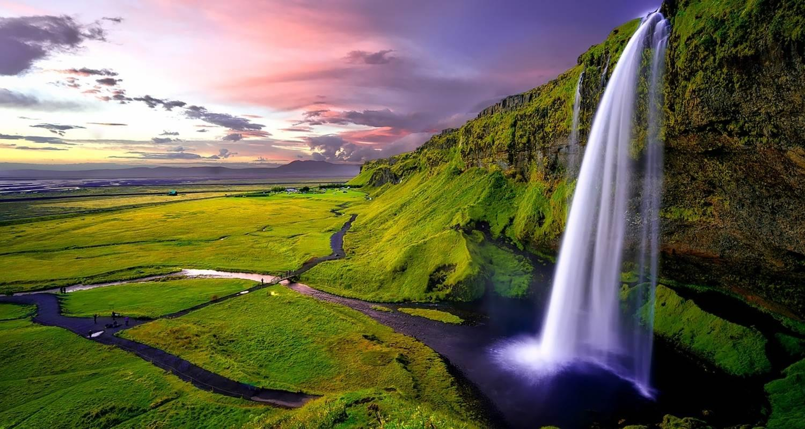

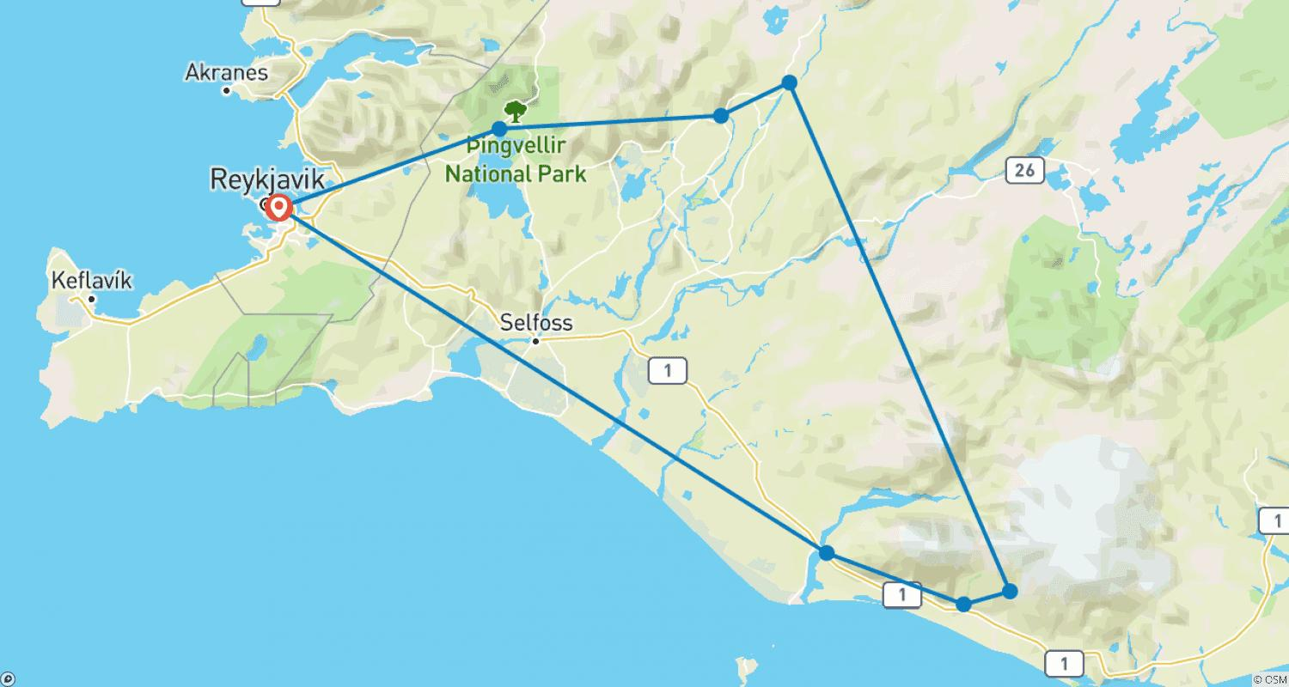

Tour ID: 88570  
Tour Name: 6 Day - Around Iceland Adventure

Tour destinations: ['Reynisfjara', 'Skogafoss', 'Geysir', 'Gullfoss', 'Kirkjubaejarklaustur', 'Jokulsarlon', 'Skaftafell', 'Hofn', 'Djupivogur', 'Egilsstadir', 'Dettifoss', 'Dimmuborgir', 'Akureyri', 'Dalvik', 'Siglufjordur', 'Laugarbakki', 'Borgarfjörður', 'Hraunfossar', 'Reykholt']

Tour destinations images:

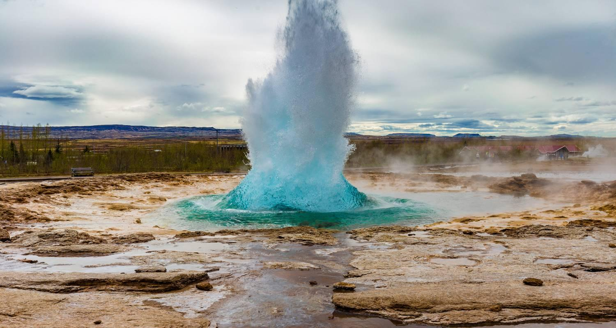

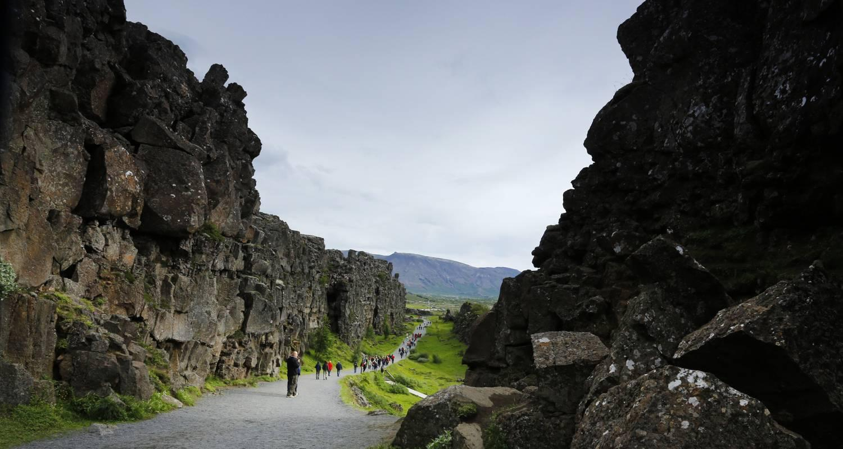

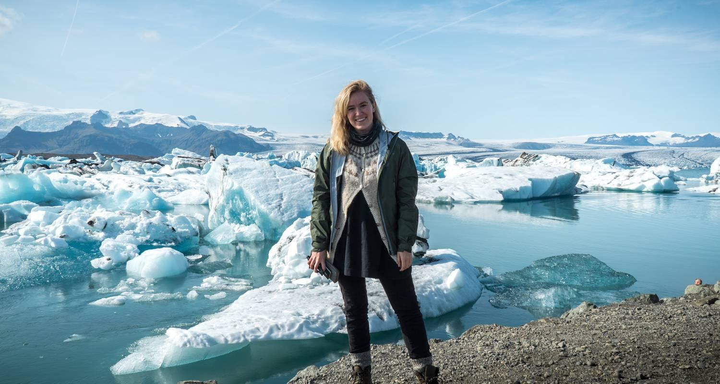

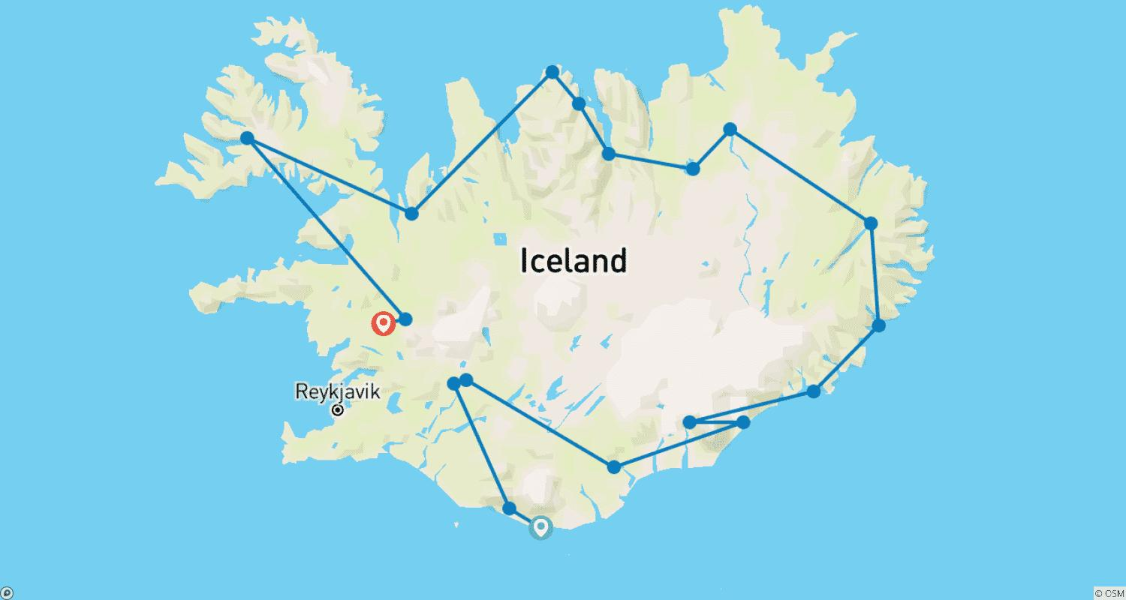

Tour ID: 91452  
Tour Name: Premium Iceland

Tour destinations: ['Reykjavik', 'Thingvellir National Park', 'Borgarfjörður', 'Snaefellsjokull National Park', 'Akureyri', 'Husavik', 'Myvatn', 'Egilsstadir', 'Jokulsarlon', 'Skaftafell', 'Hella']

Tour destinations images:

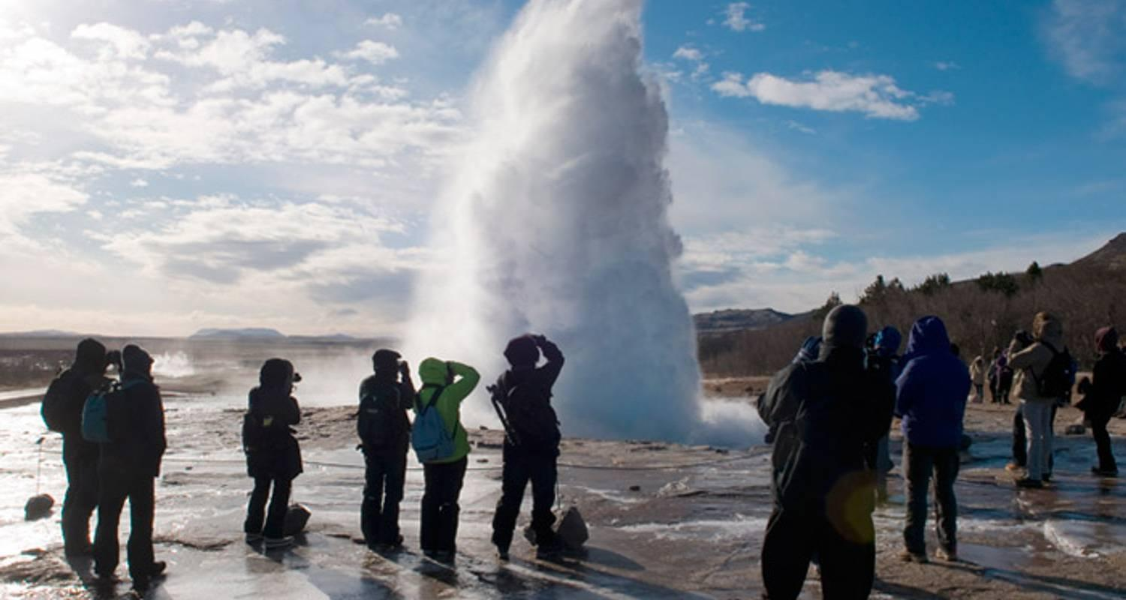

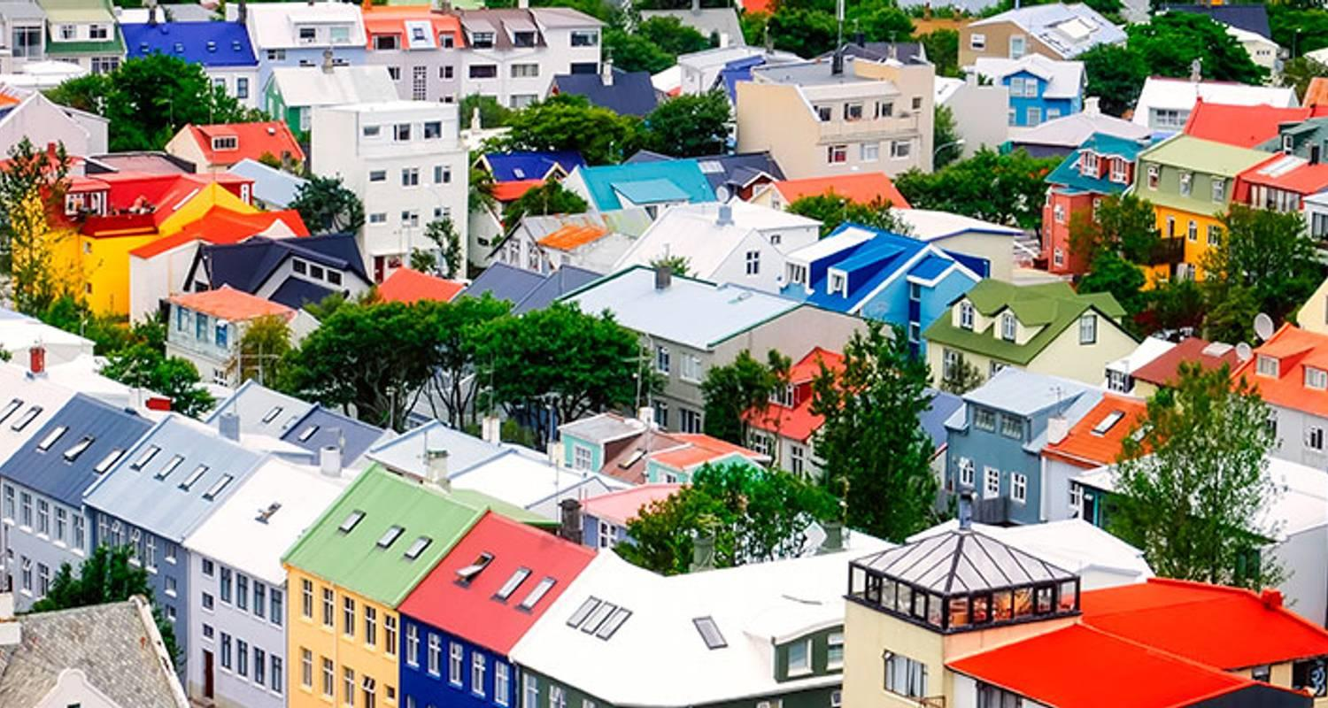

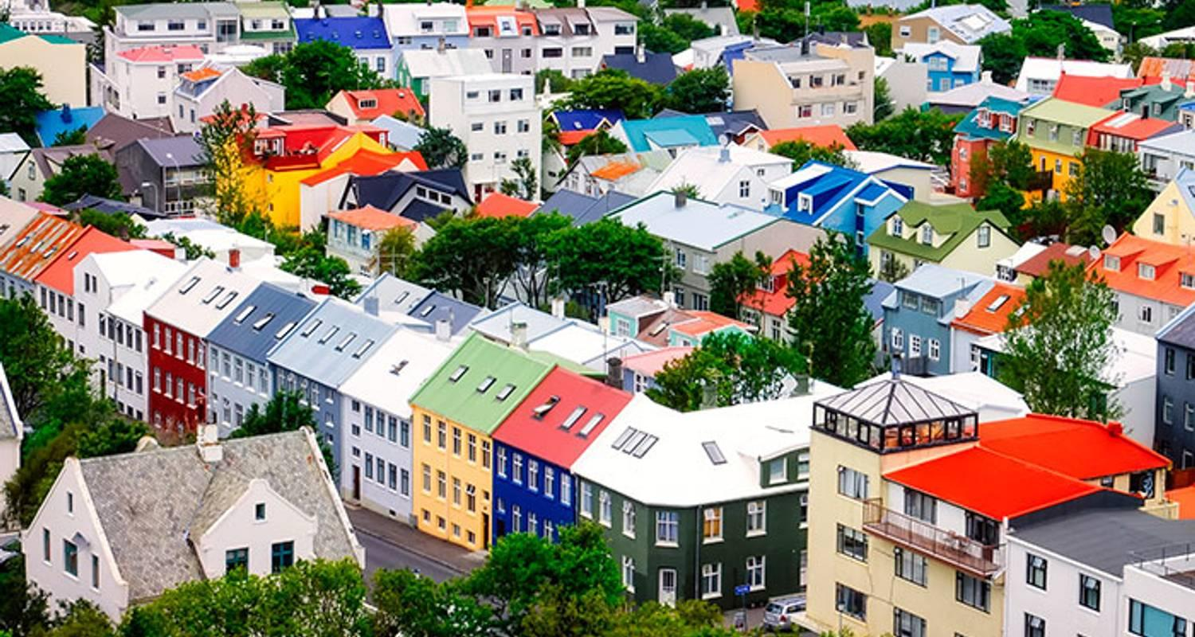

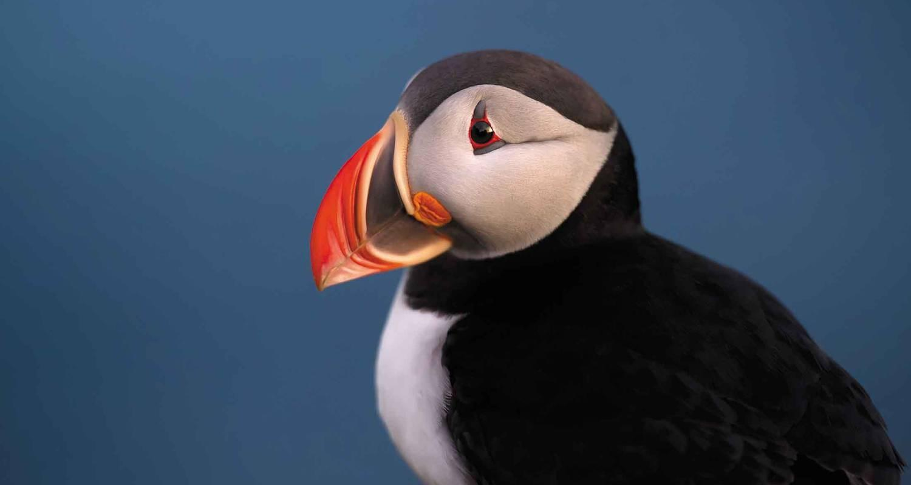

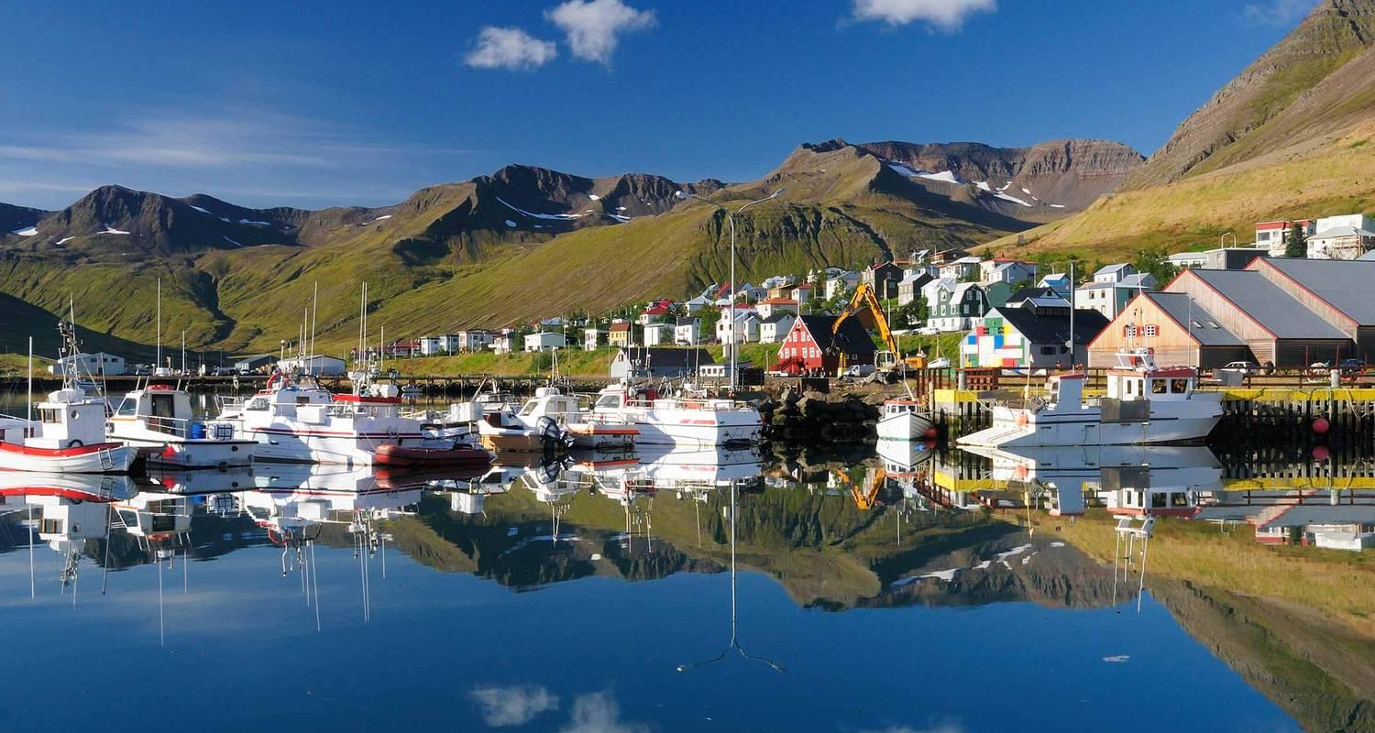

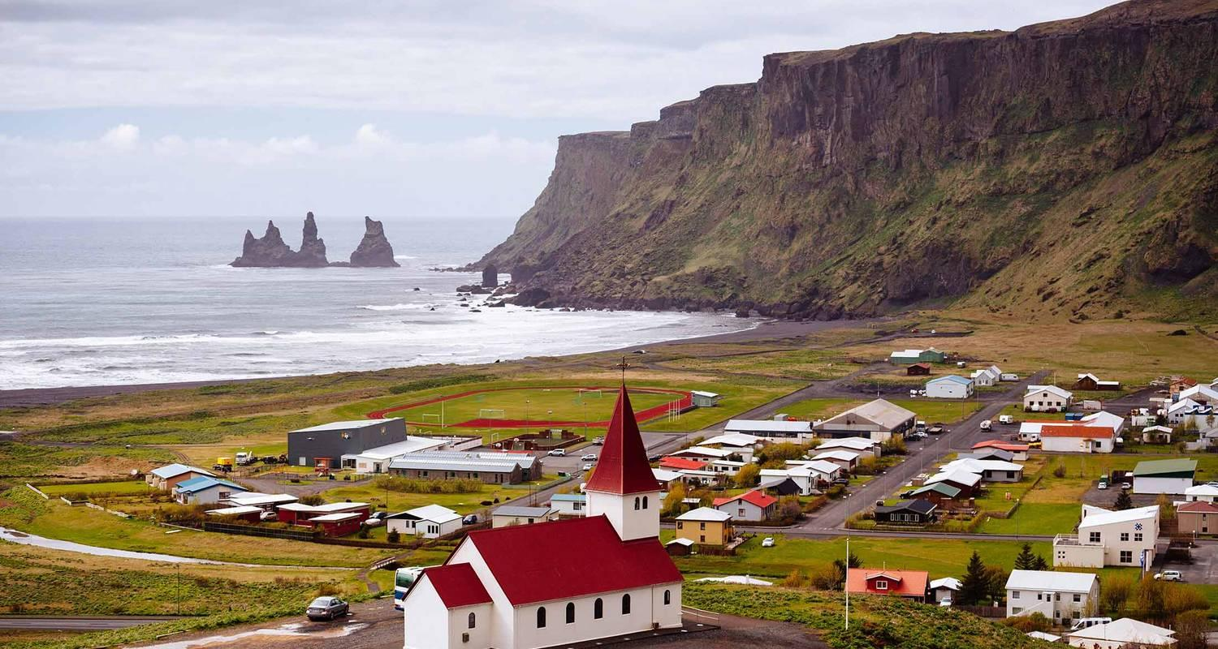

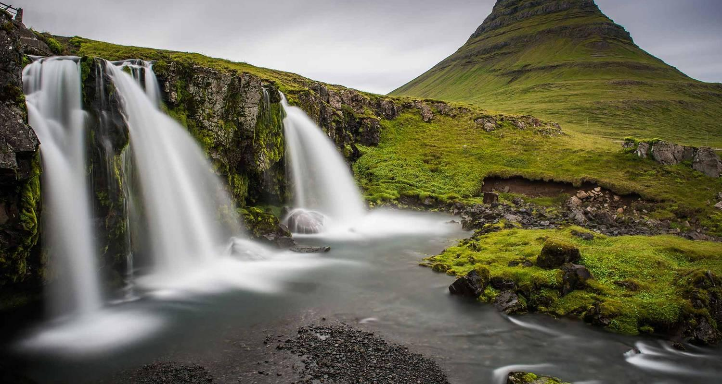

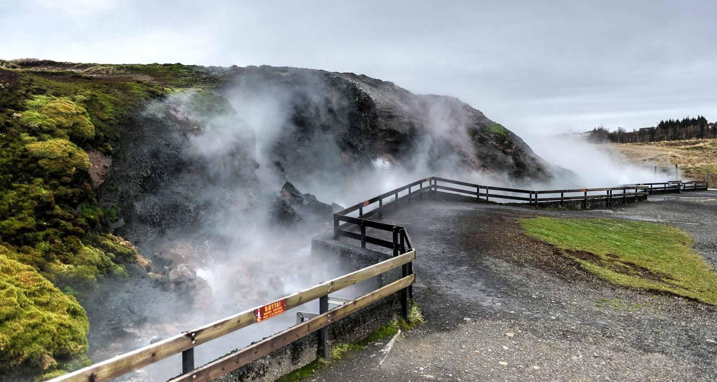

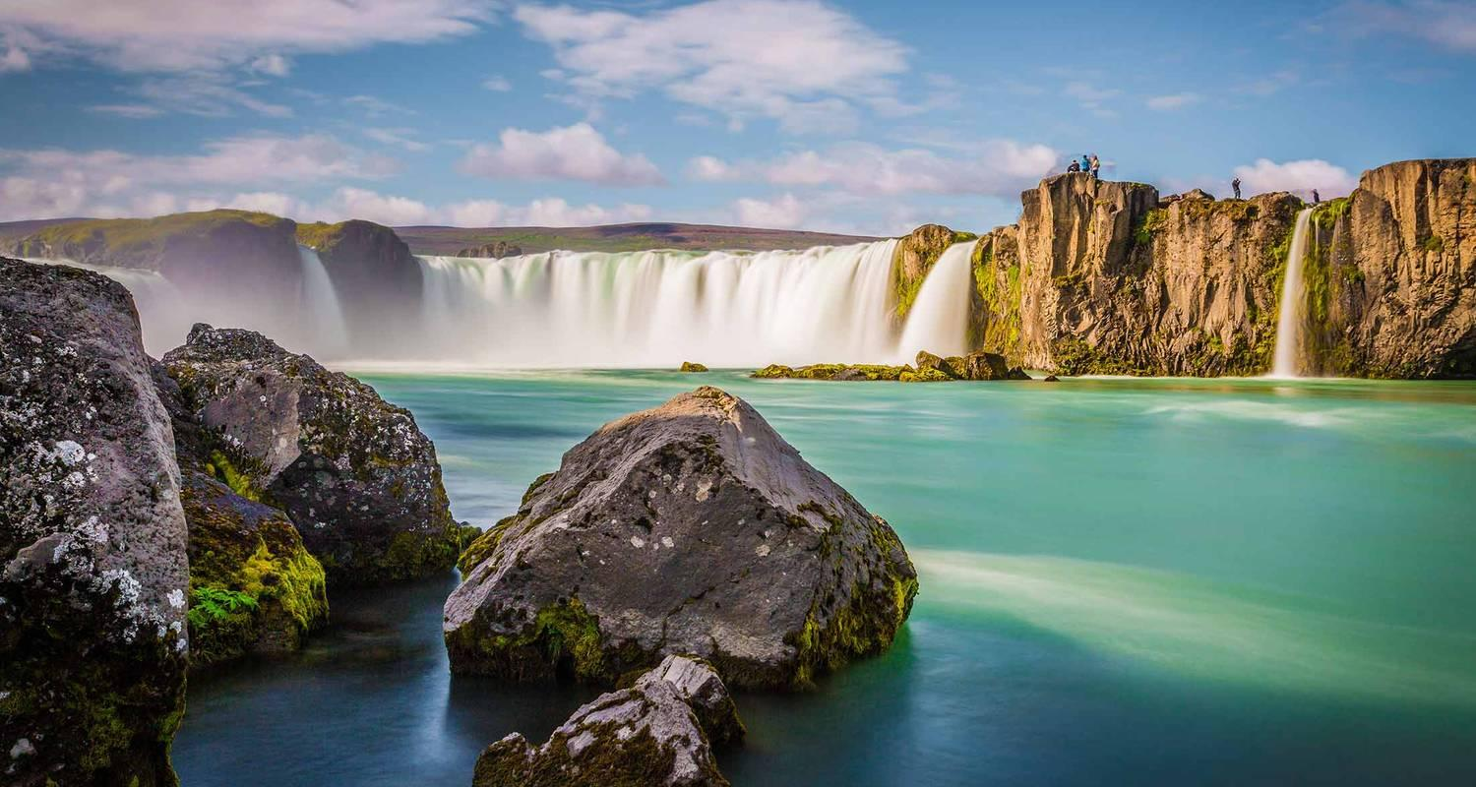

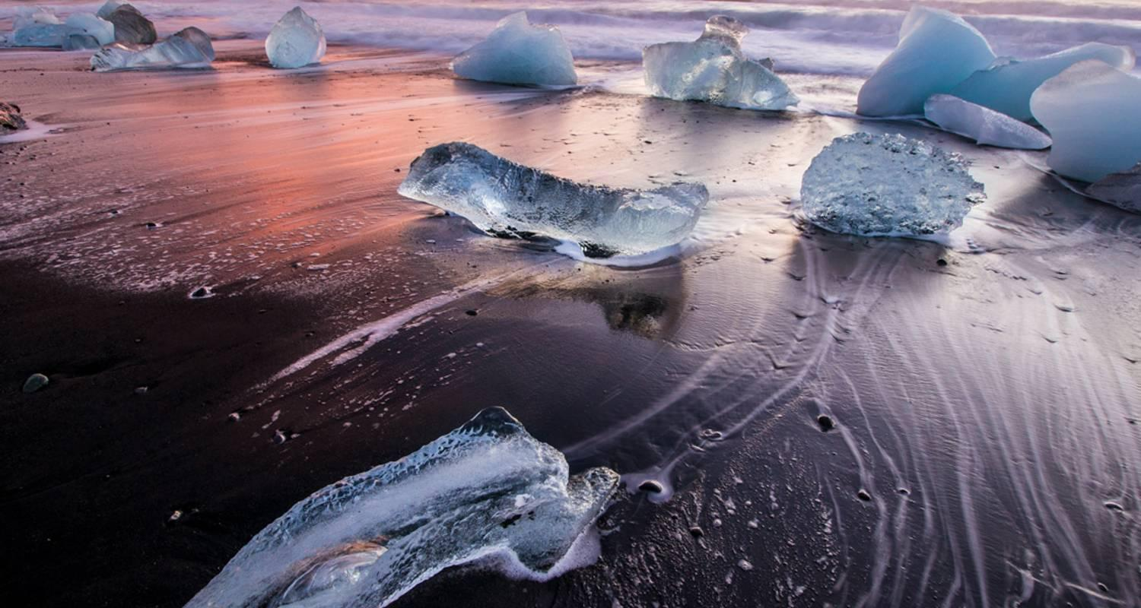

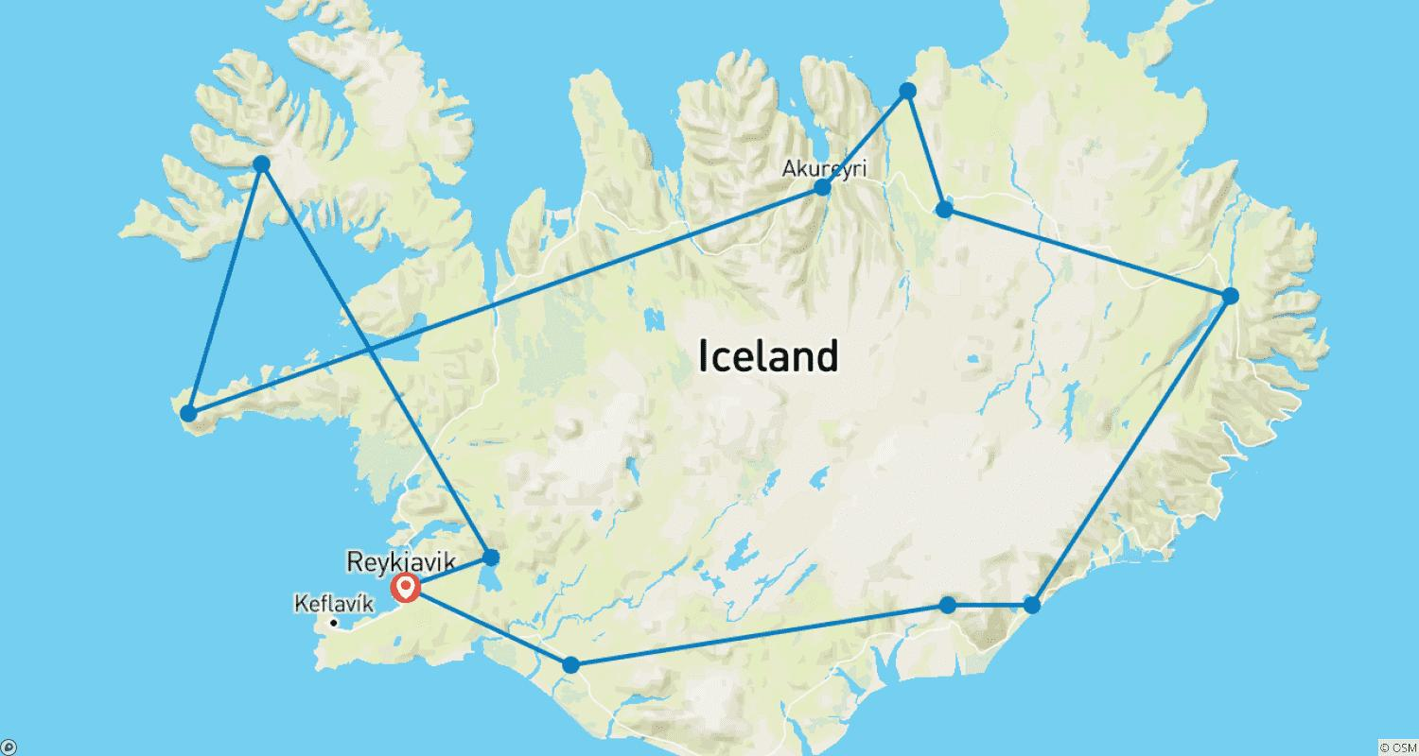

Tour ID: 91647  
Tour Name: Iceland Express

Tour destinations: ['Reykjavik', 'Skogafoss', 'Hvolsvollur', 'Myrdalsjokull', 'Jokulsarlon', 'Vik']

Tour destinations images:

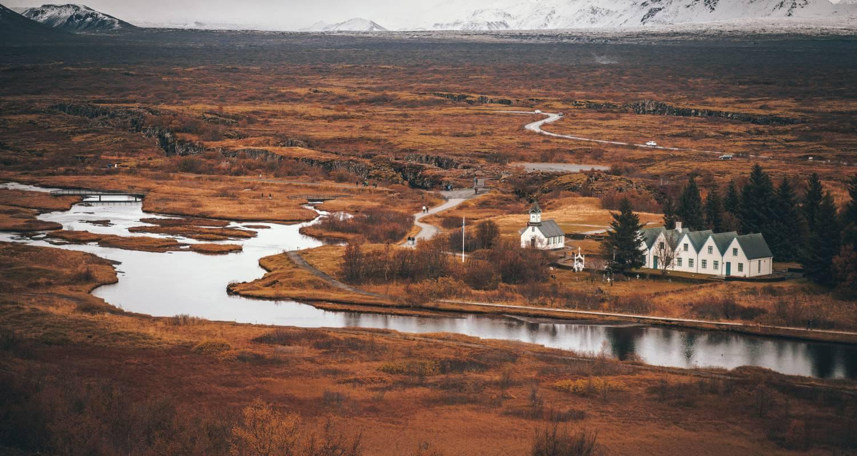

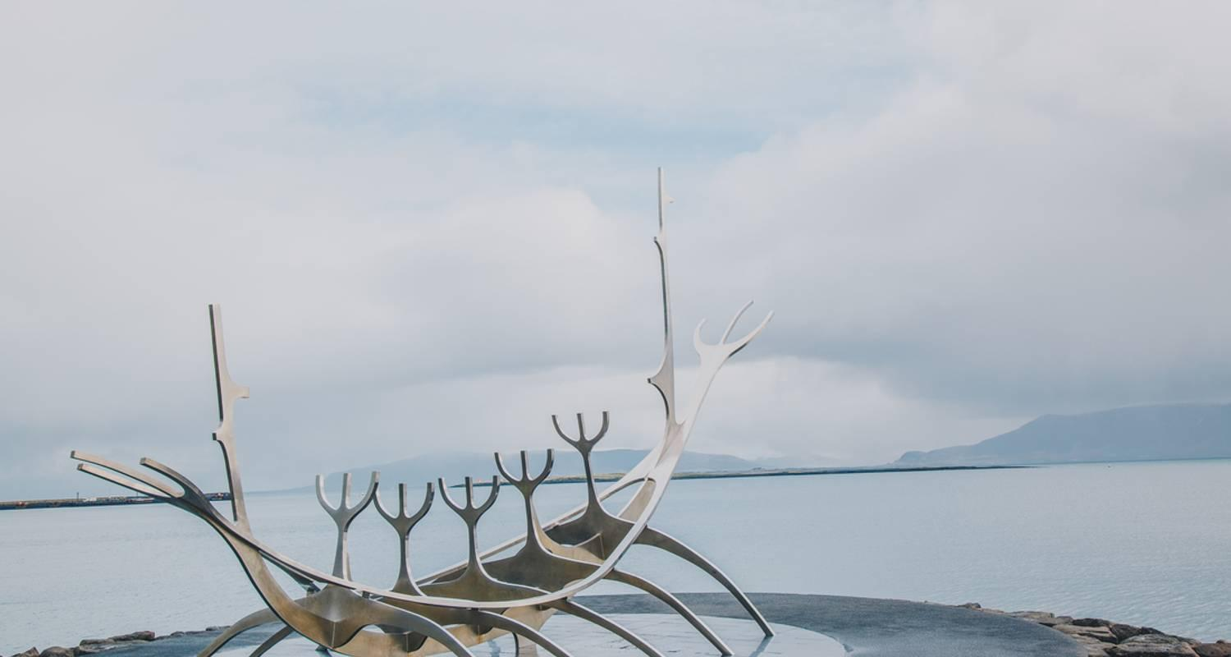

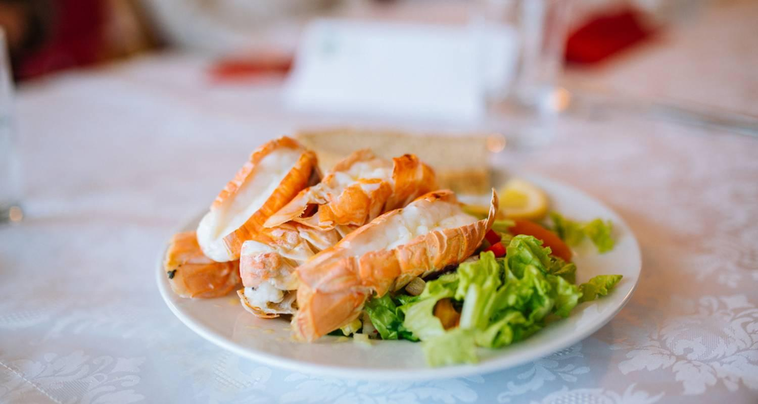

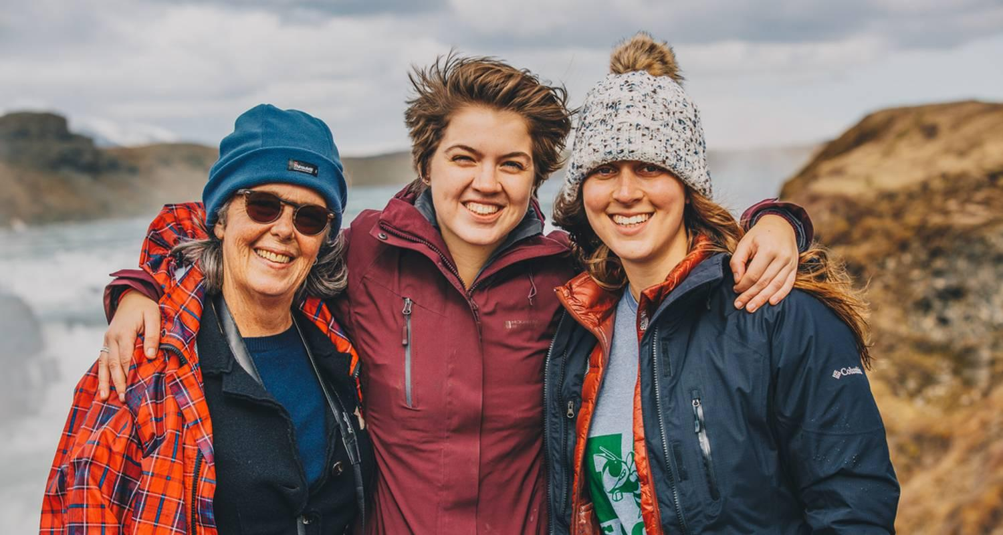

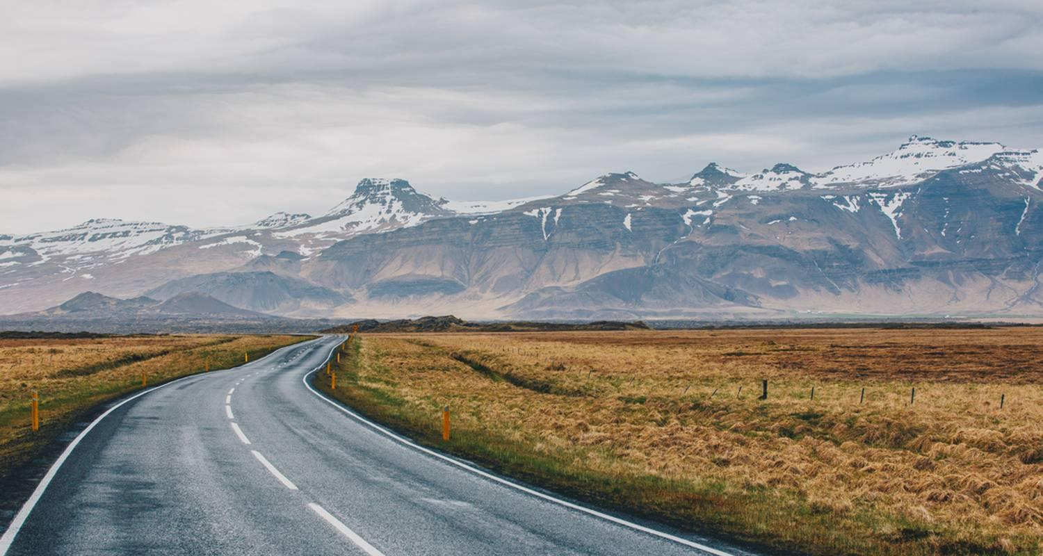

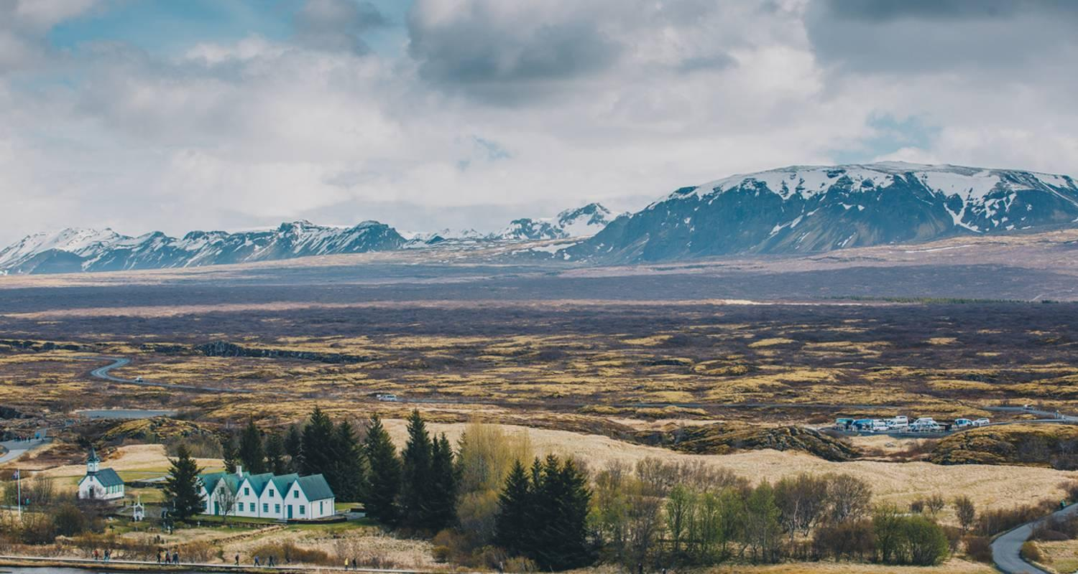

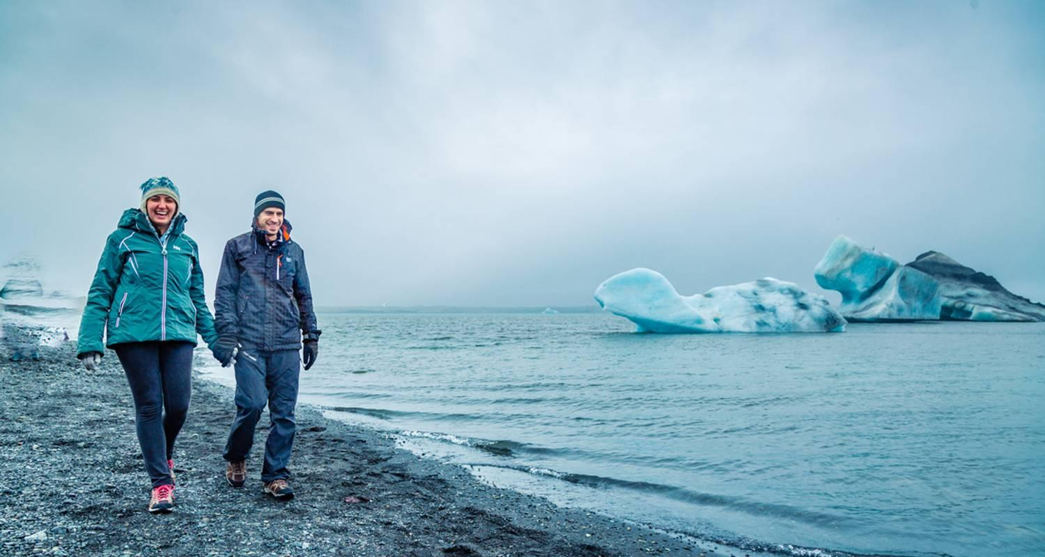

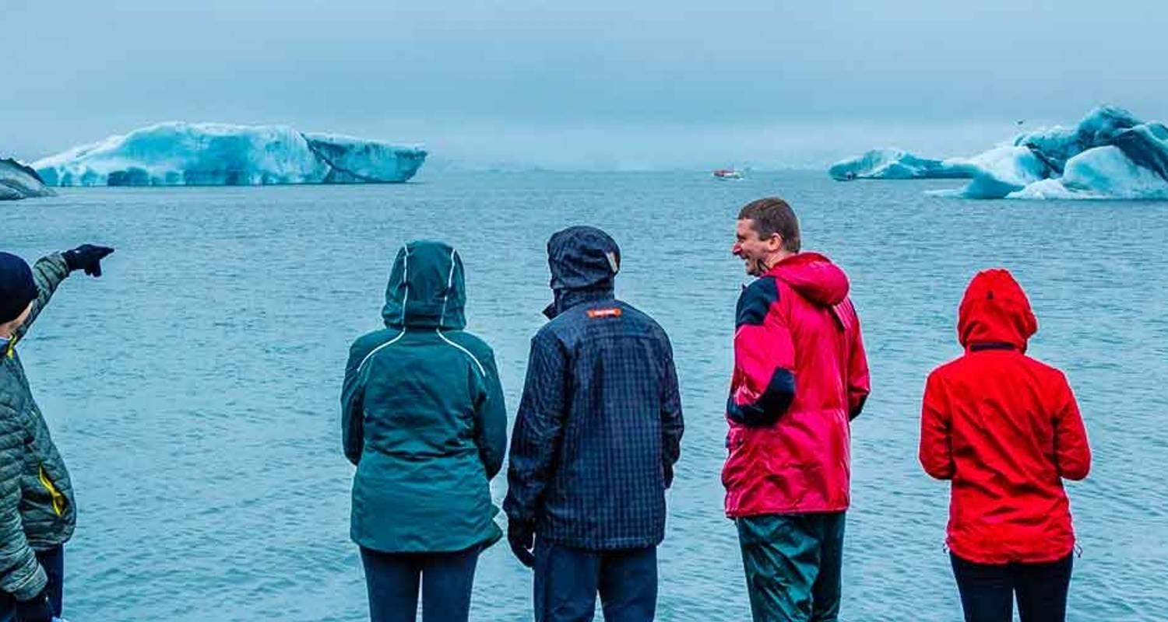

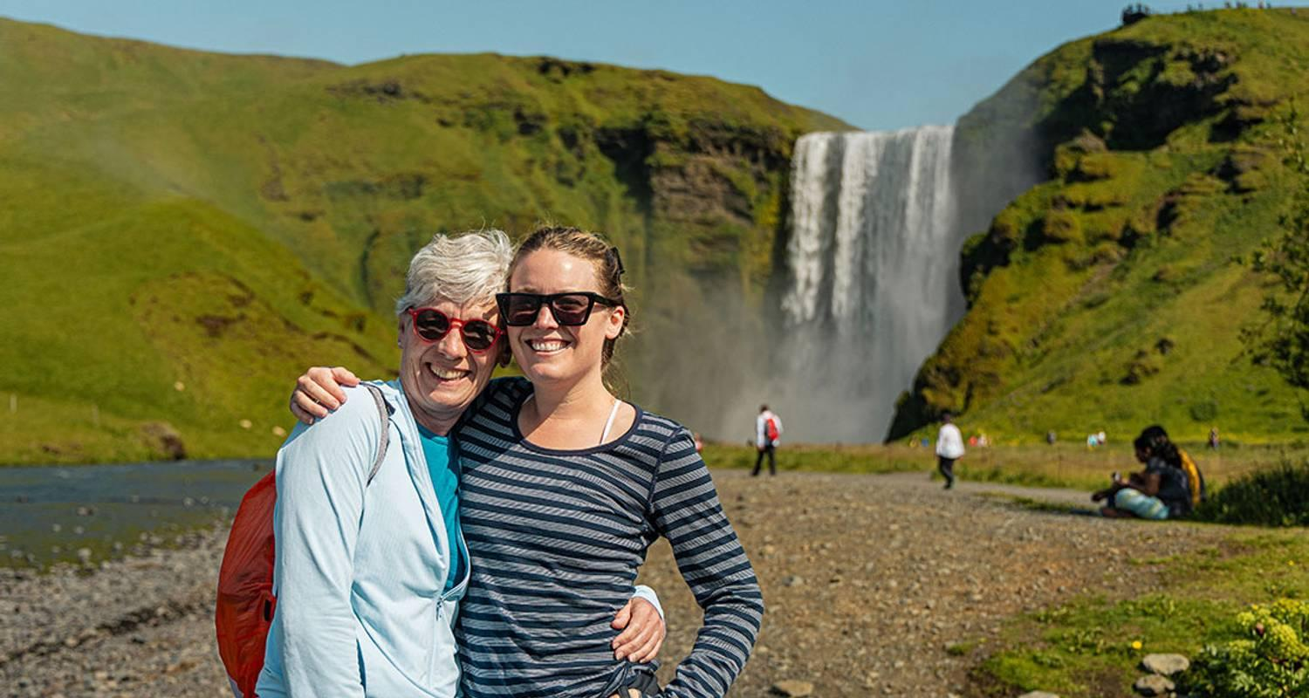

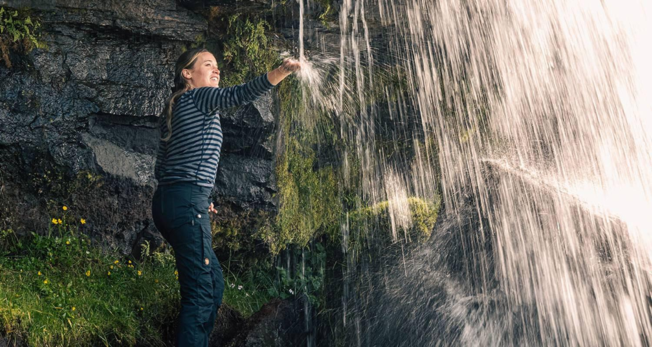

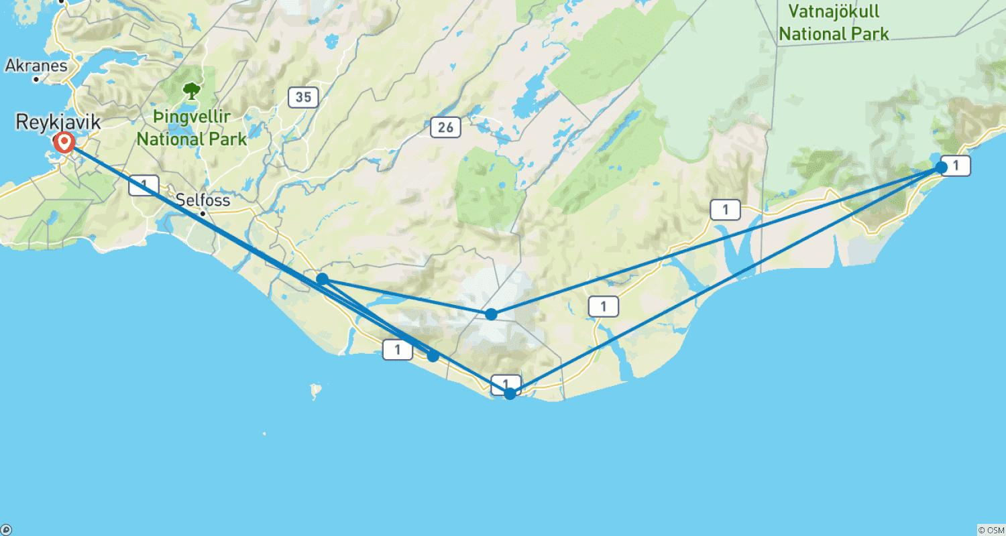

Tour ID: 92440  
Tour Name: 3 Day - Golden Circle, South Coast, Jökulsárlón & Ice Cave

Tour destinations: ['Reykjavik', 'Thingvellir National Park', 'Dover', 'Gullfoss', 'Hekla Volcano', 'Seljaland', 'Skogafoss', 'Vik', 'Reynisfjara', 'Jokulsarlon', 'Skaftafell', 'Fjadrargljufur']

Tour destinations images:

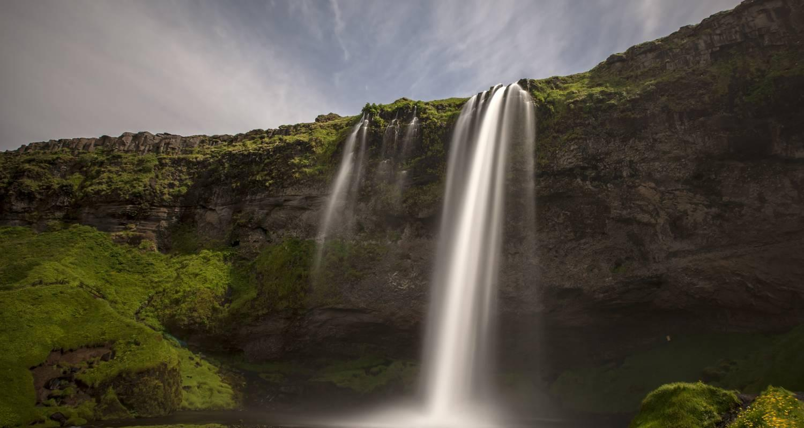

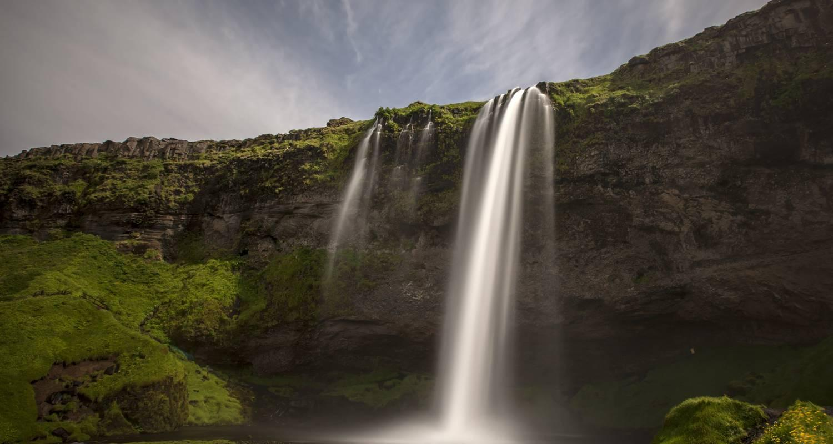

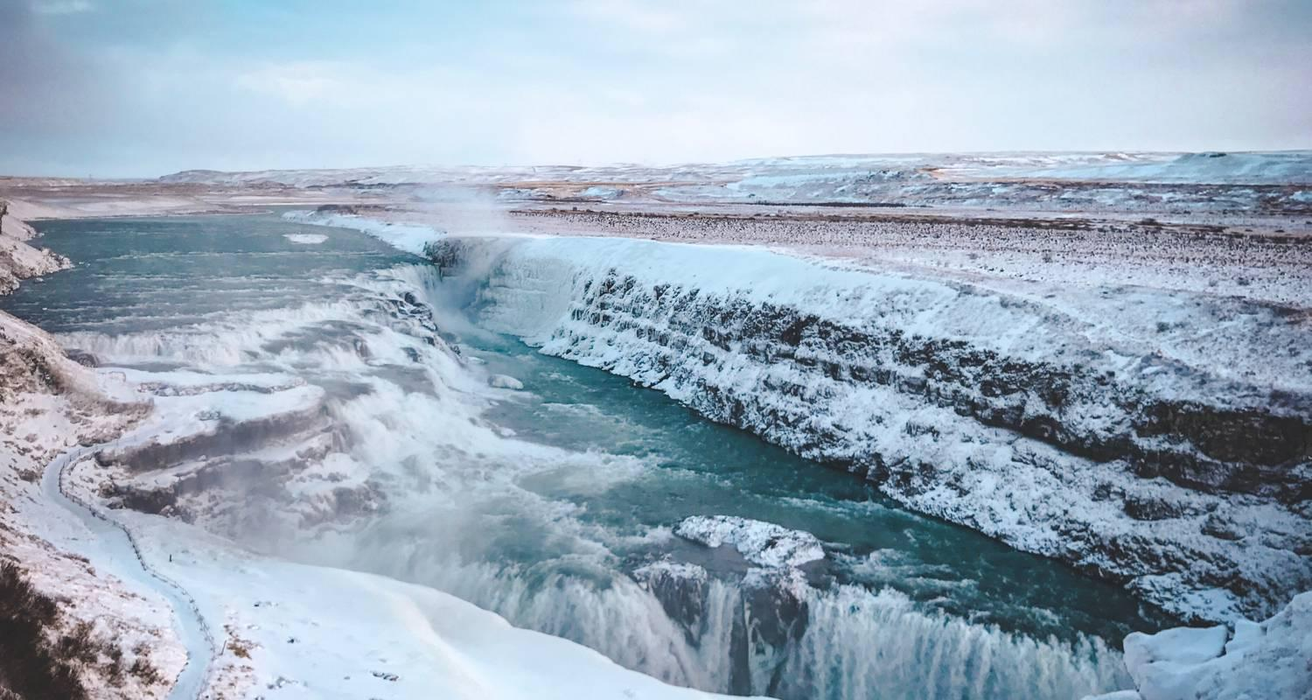

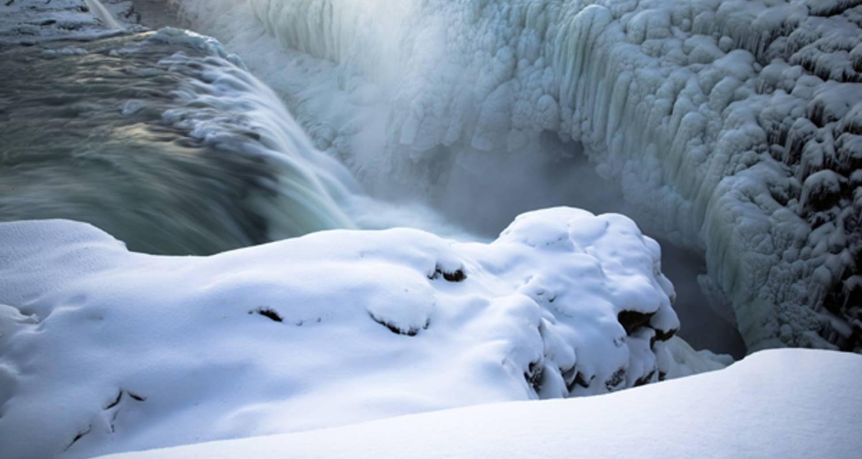

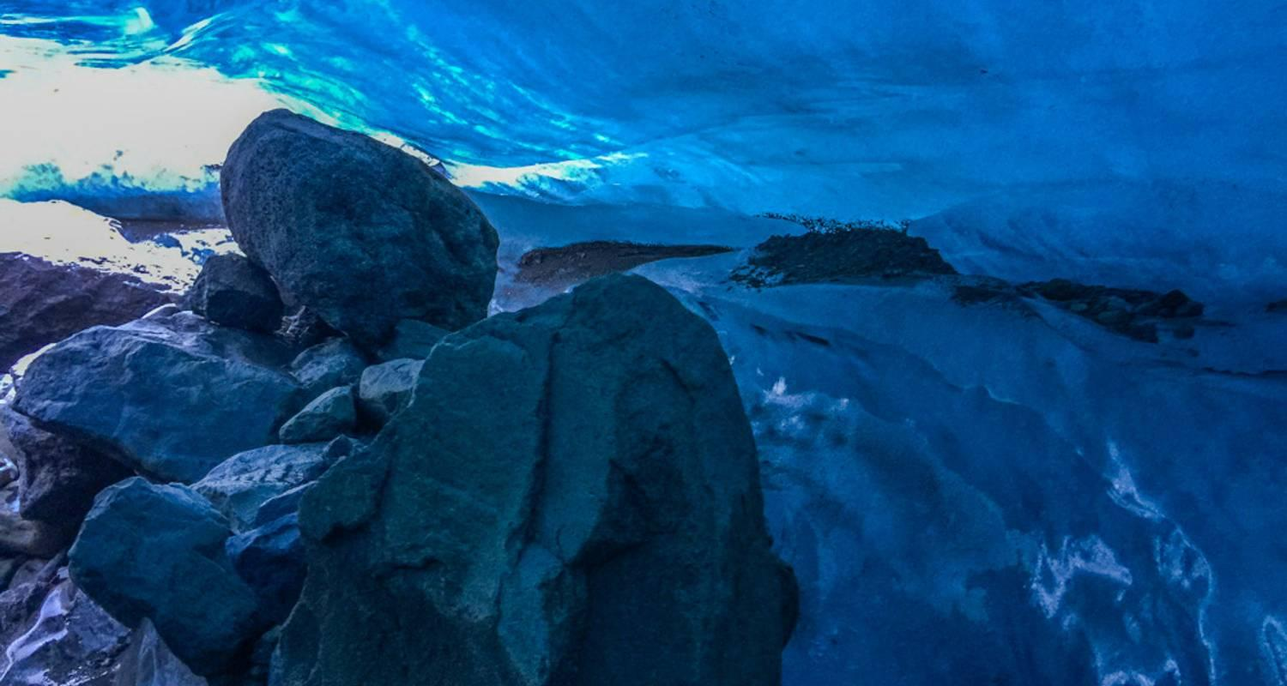

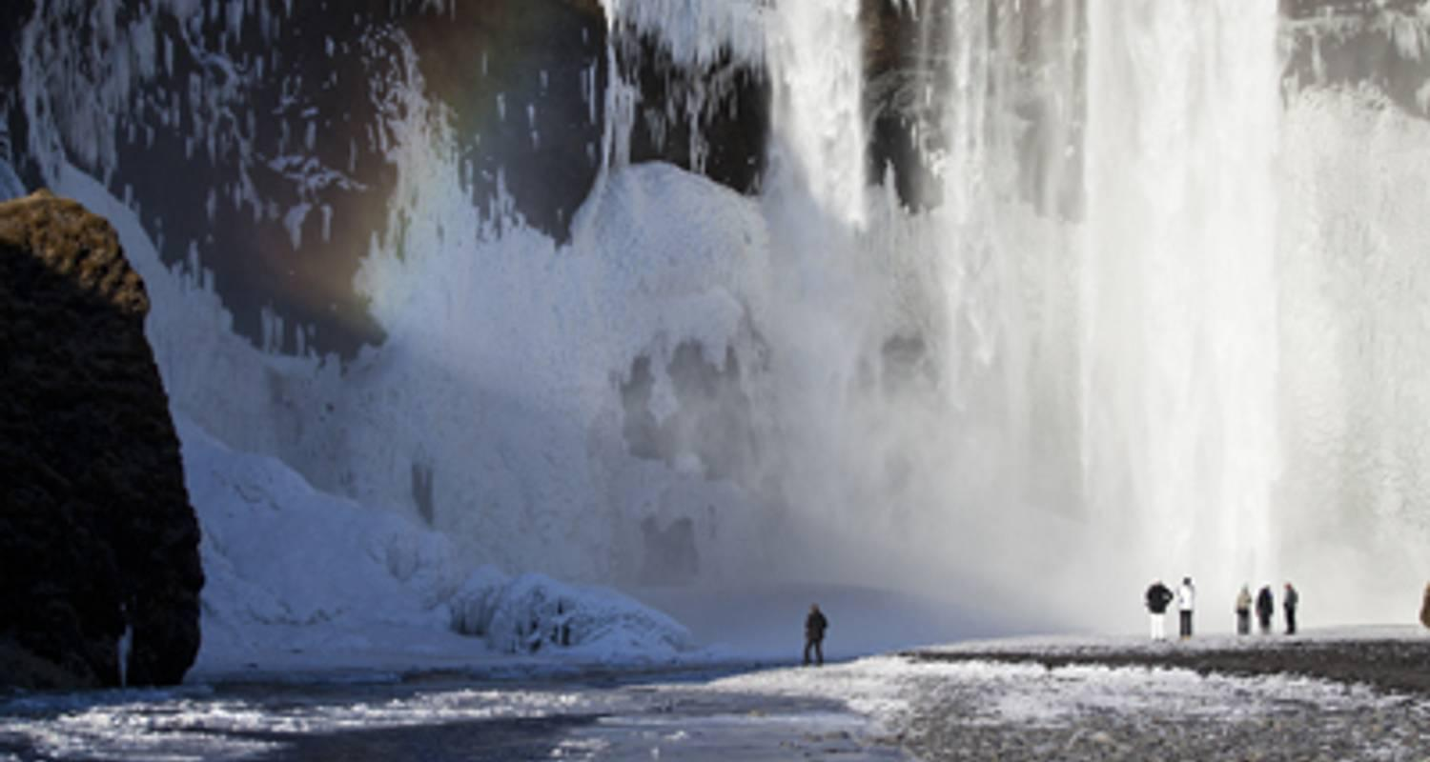

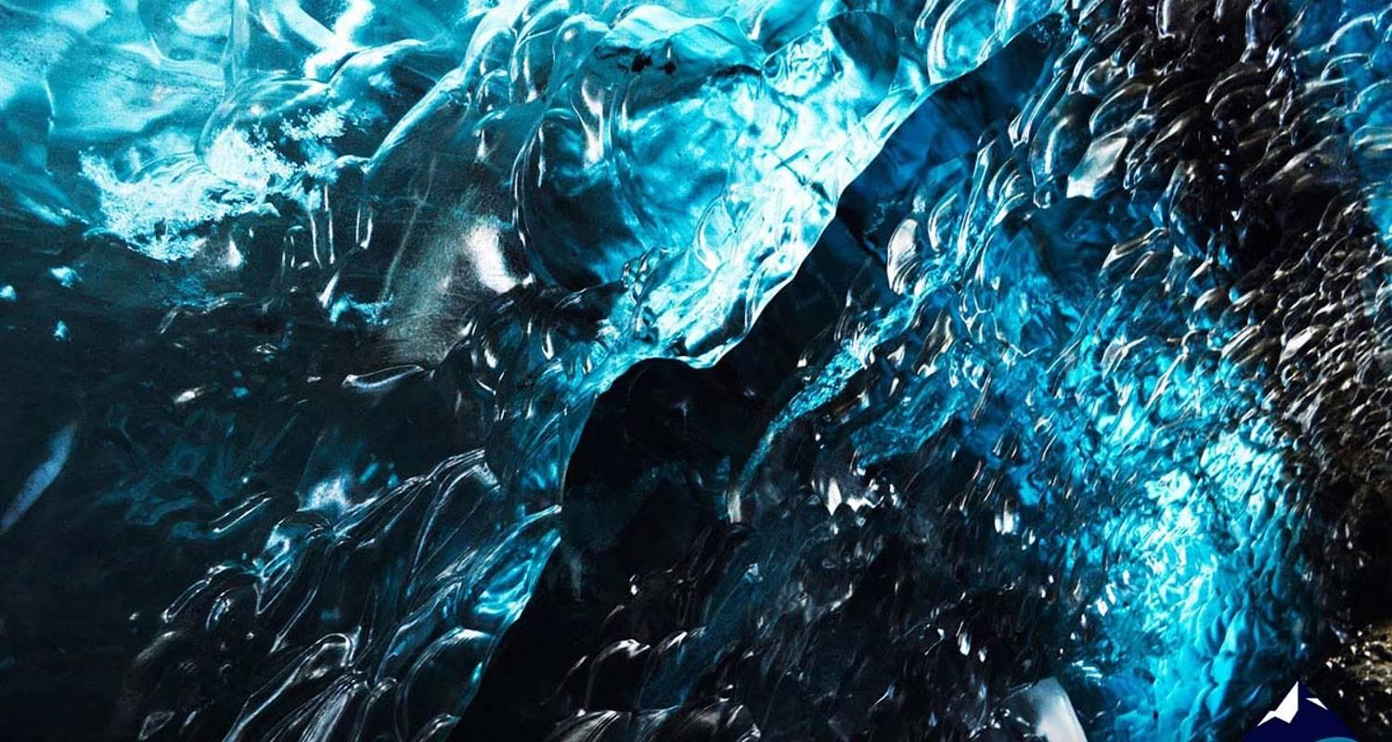

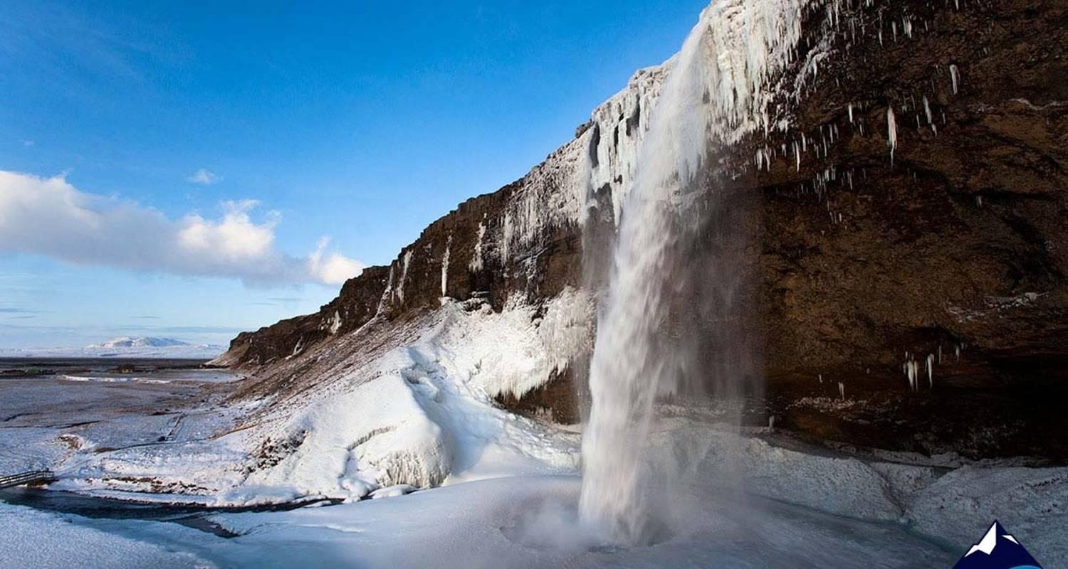

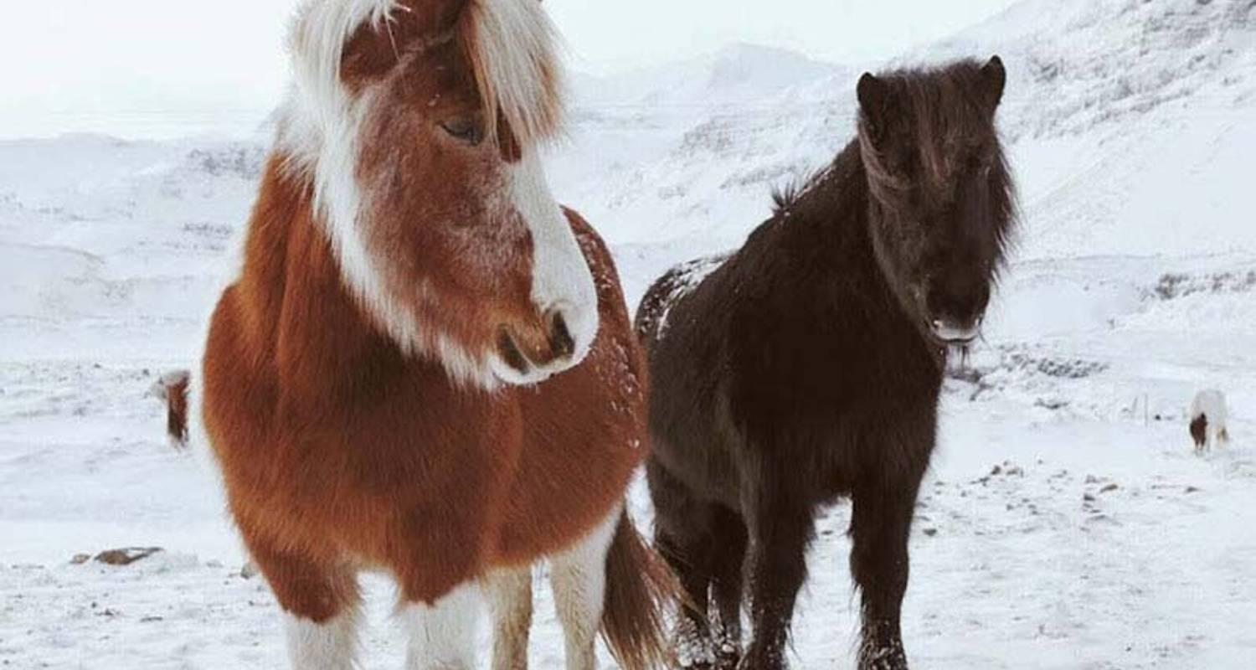

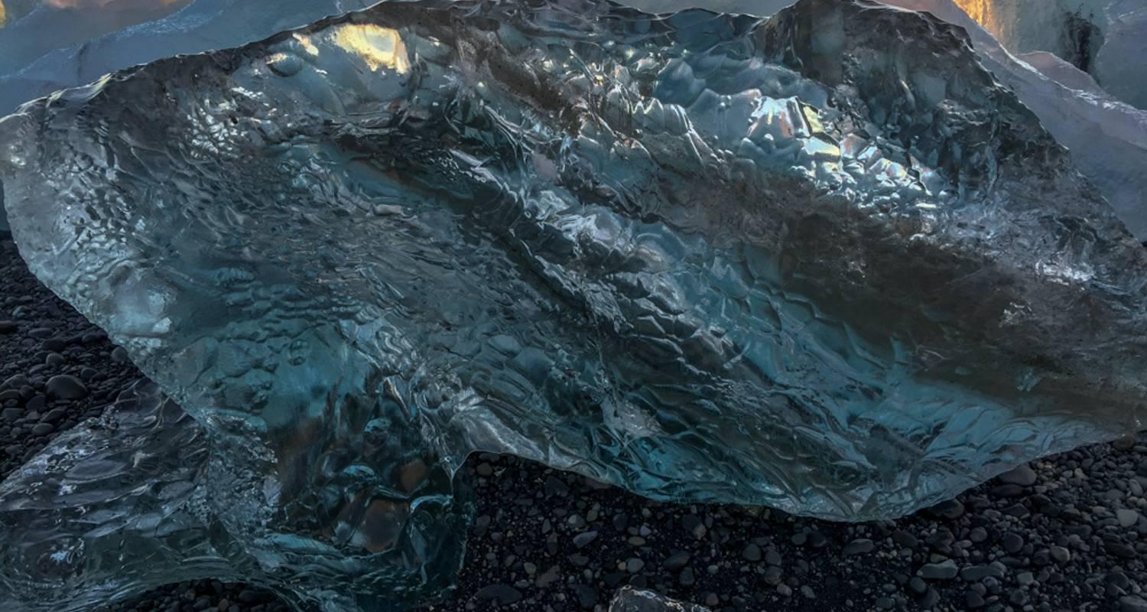

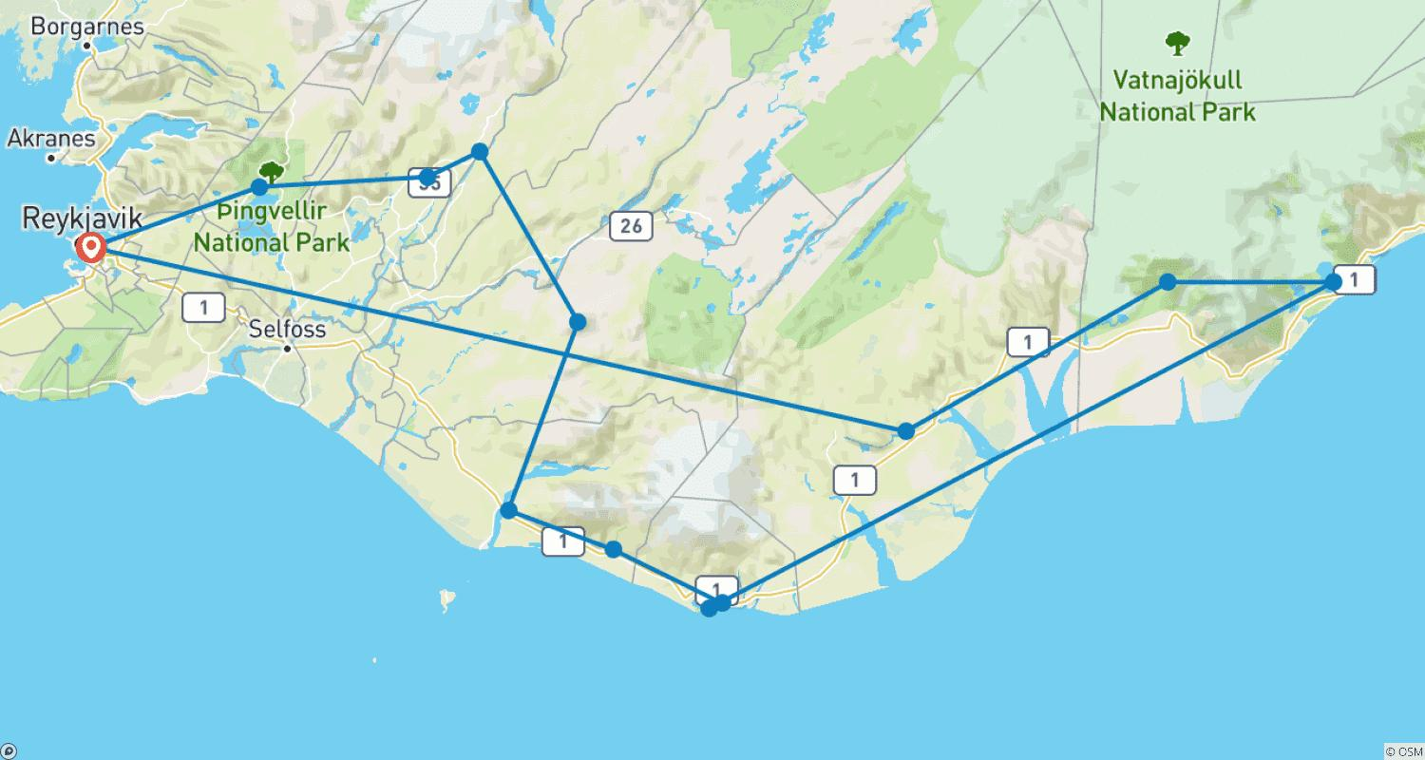

Tour ID: 92660  
Tour Name: Gems of Iceland with Whale Watching

Tour destinations: ['Reykjavik', 'Thingvellir National Park', 'Geysir', 'Gullfoss', 'Kirkjubaejarklaustur', 'Skaftafell', 'Jokulsarlon', 'Reynisfjara', 'Skogafoss', 'Seljaland']

Tour destinations images:

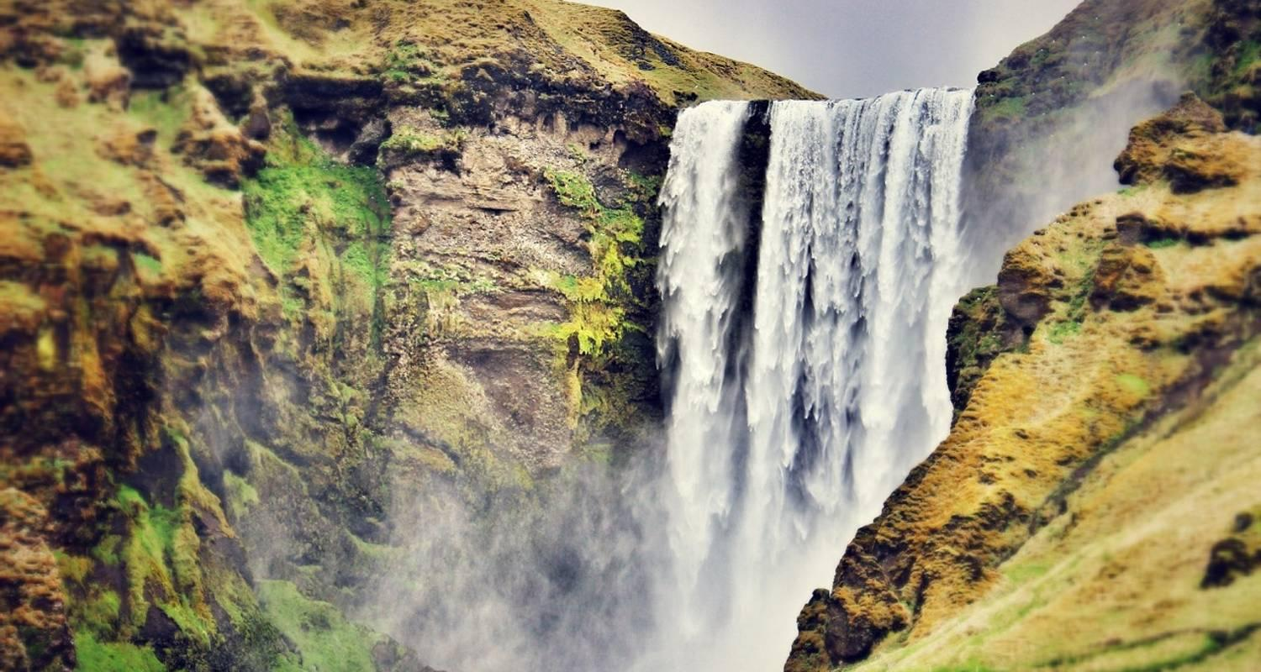

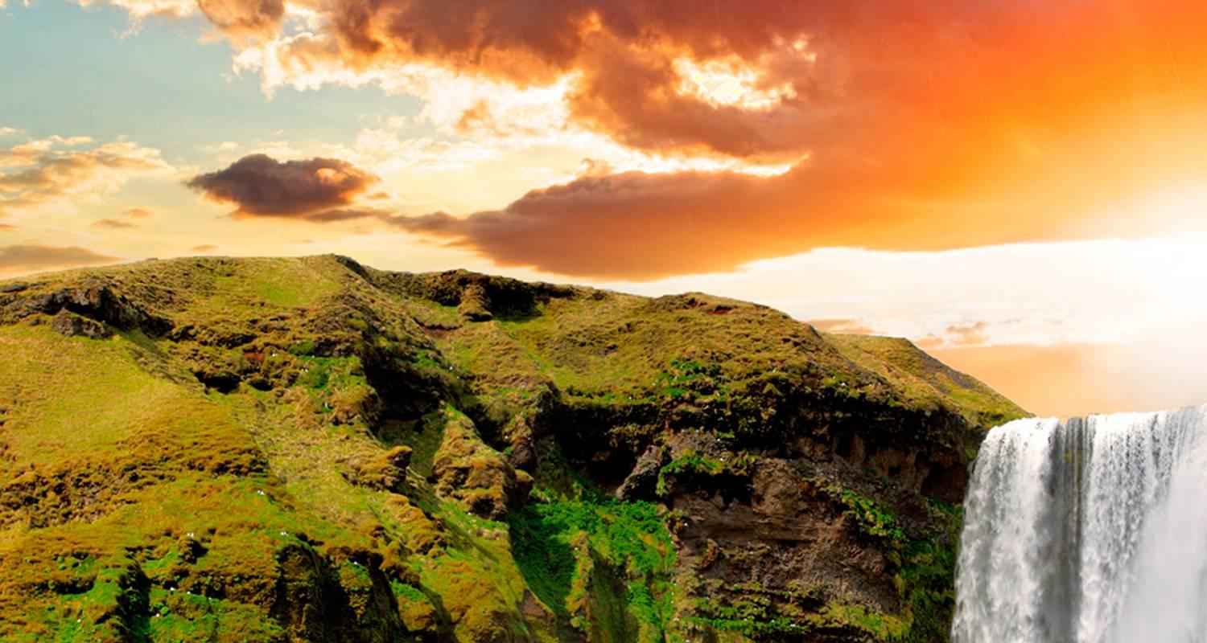

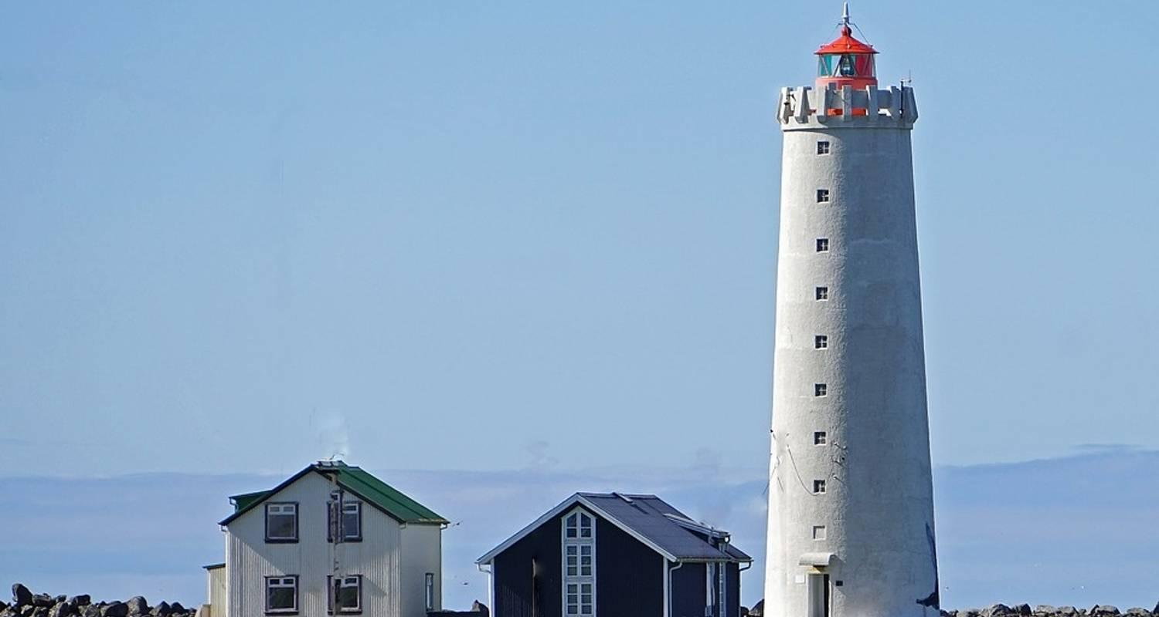

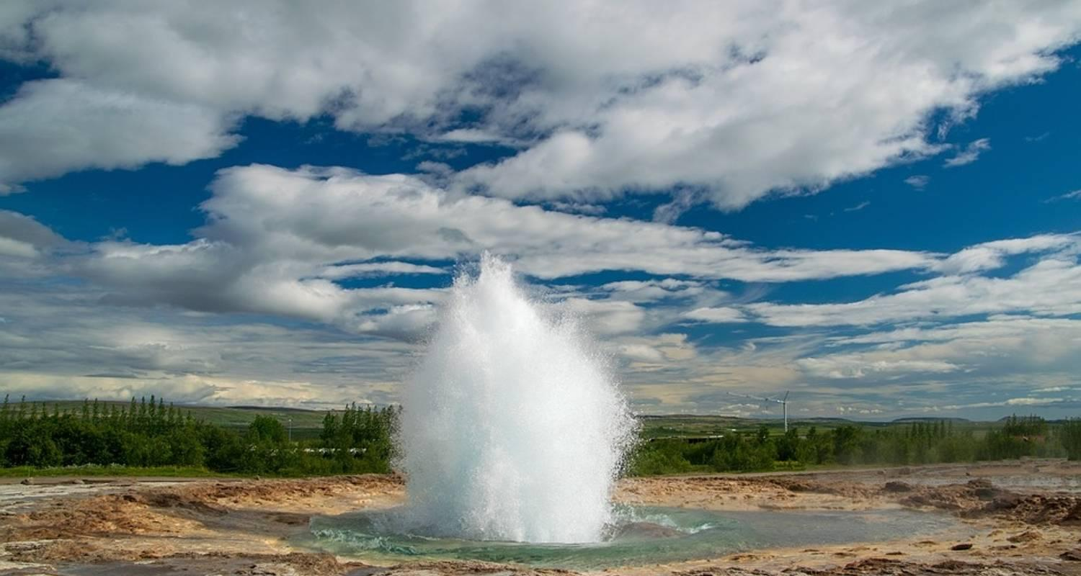

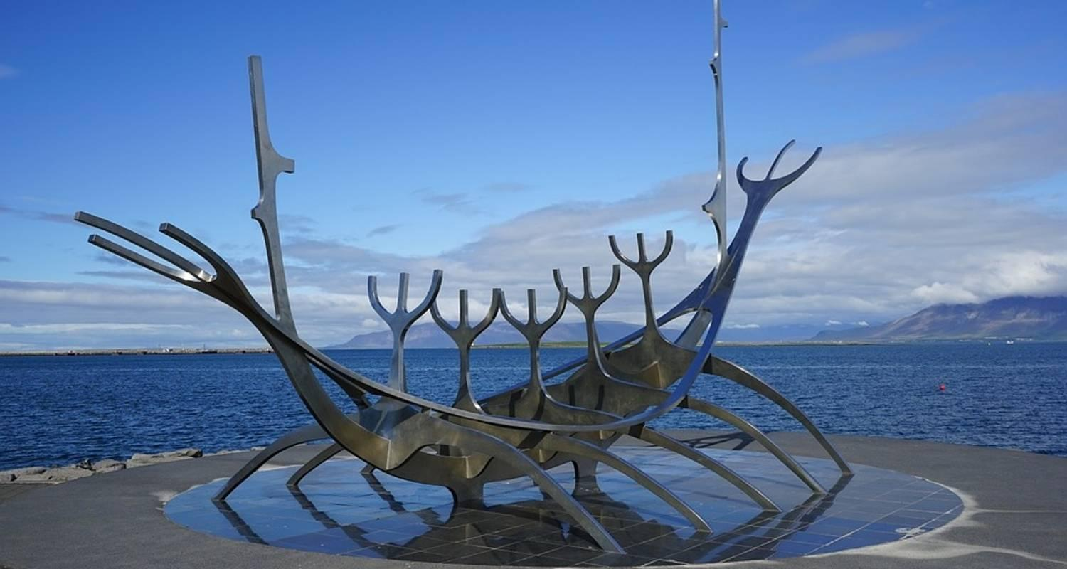

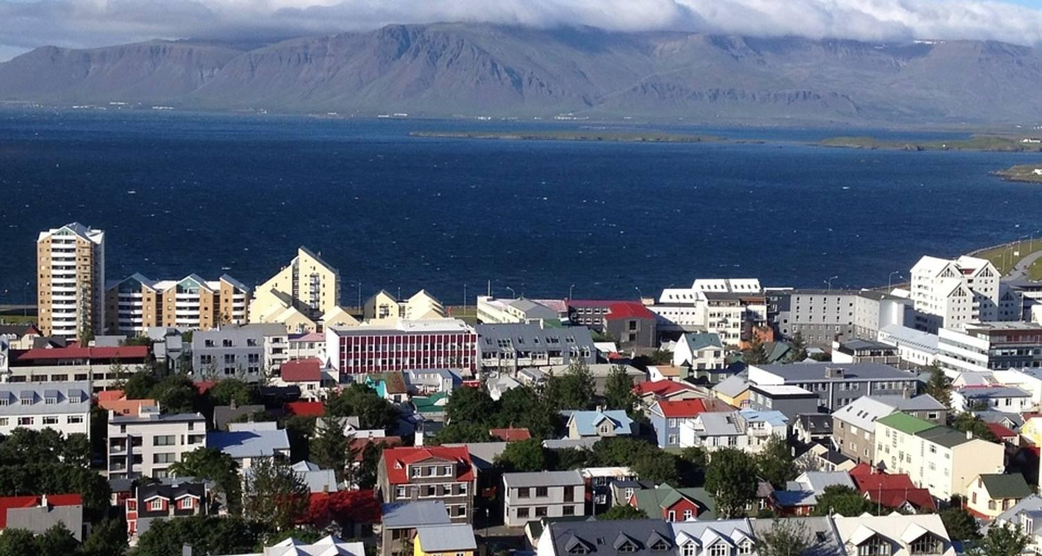



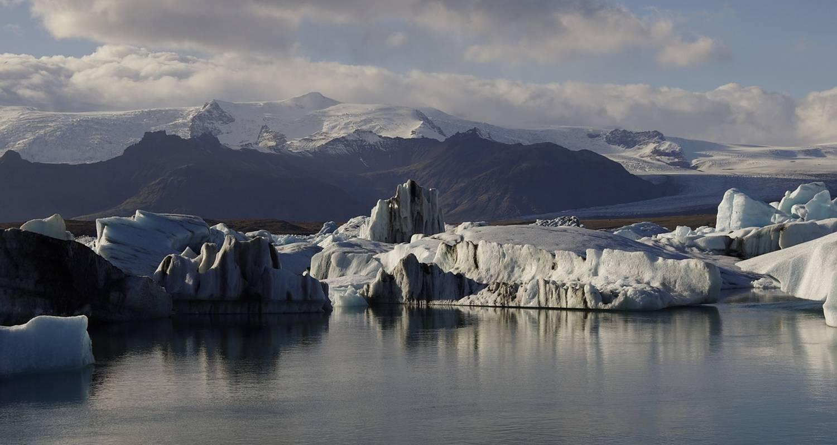



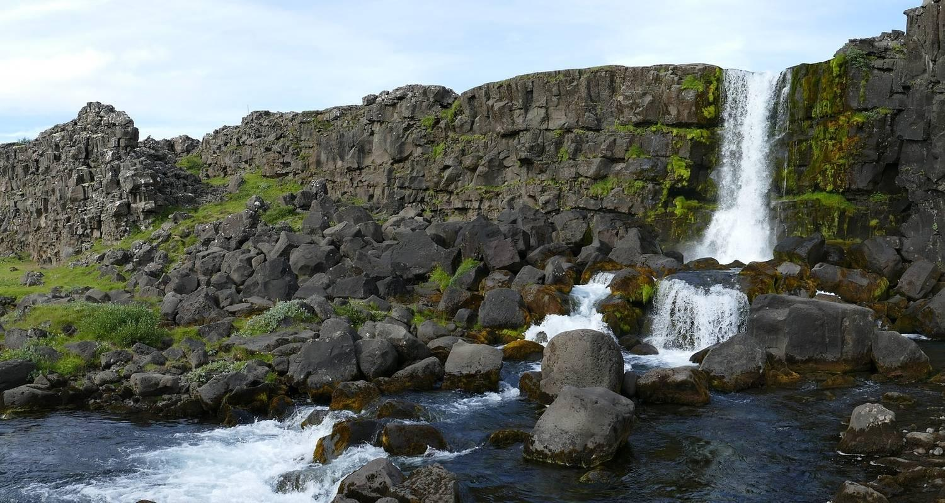

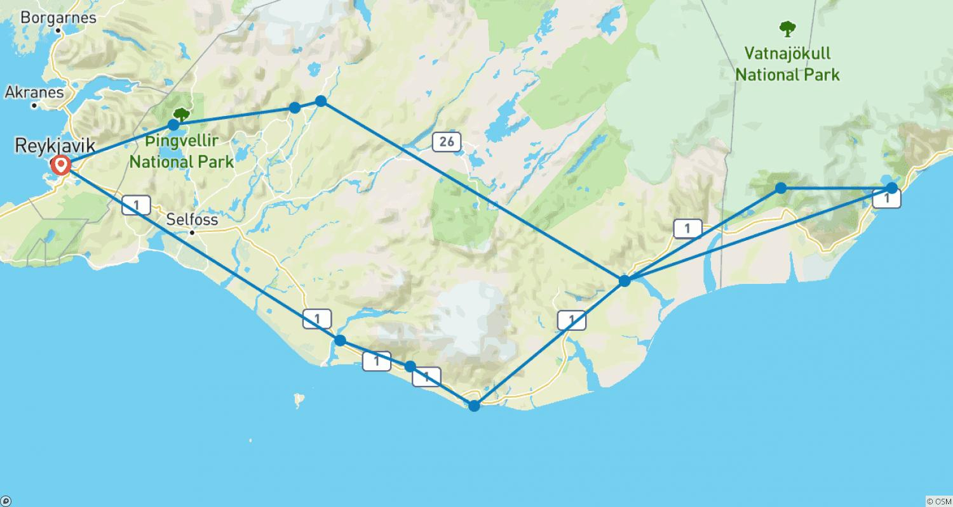

Tour ID: 93351  
Tour Name: Natural Wonders of Iceland (Classic, 9 Days)

Tour destinations: ['Reykjavik', 'Dover', 'Gullfoss', 'Vik', 'Skaftafell', 'Jokulsarlon', 'Hofn', 'Egilsstadir', 'Dettifoss', 'Godafoss', 'Myvatn', 'Akureyri', 'Hvammstangi', 'Borgarnes', 'Snaefellsjokull National Park', 'Arnarstapi', 'Thingvellir National Park']

Tour destinations images:

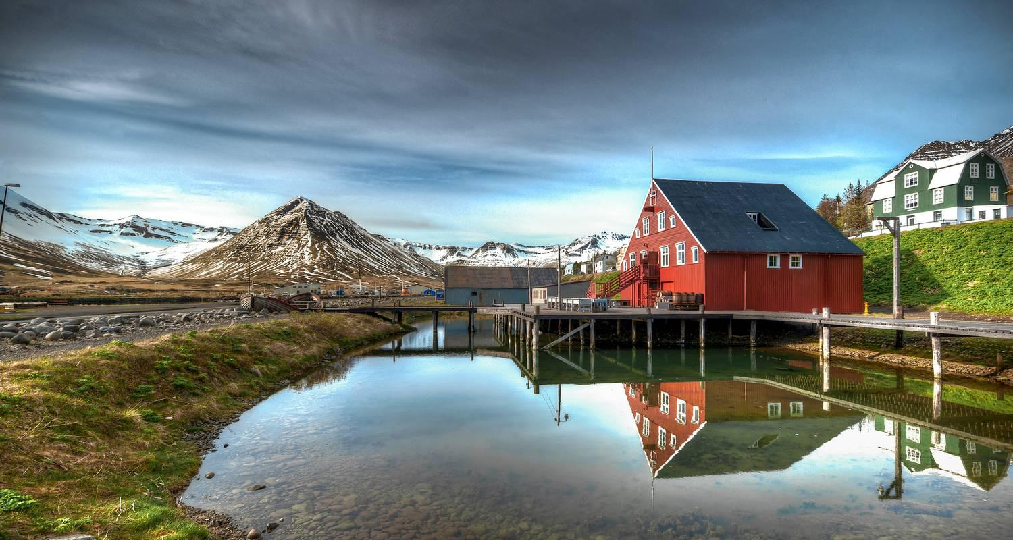

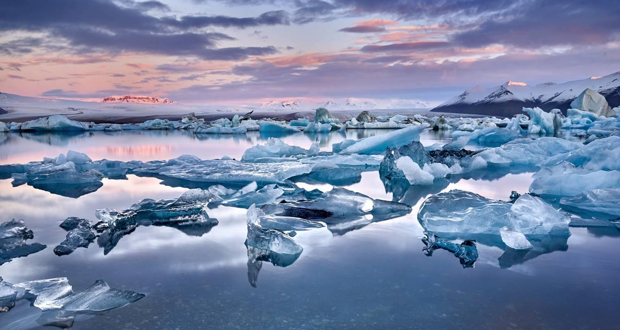

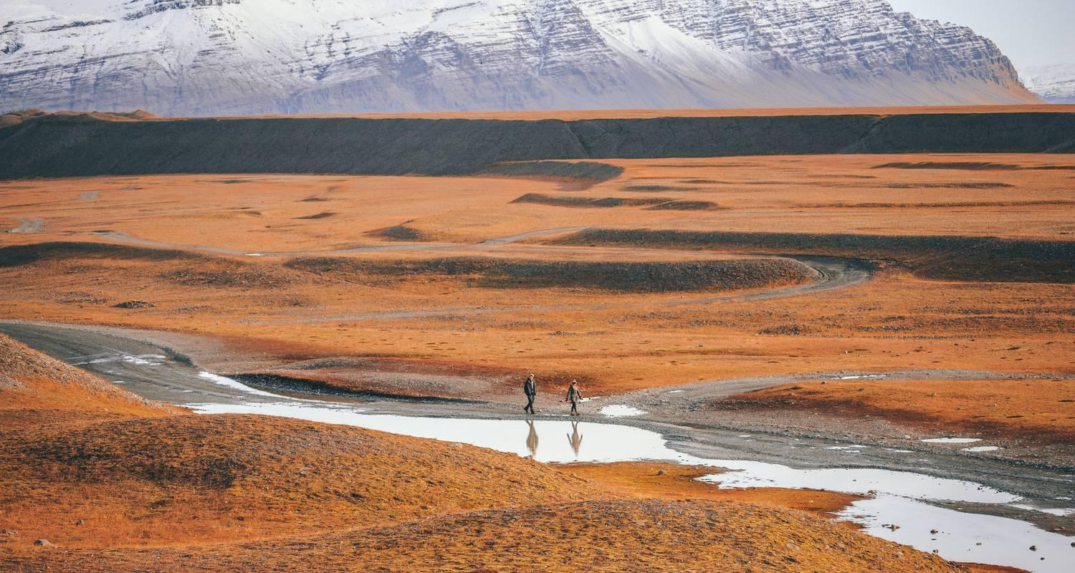

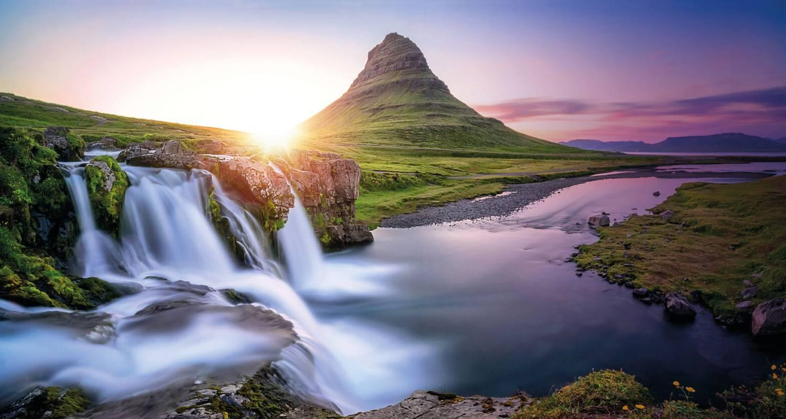

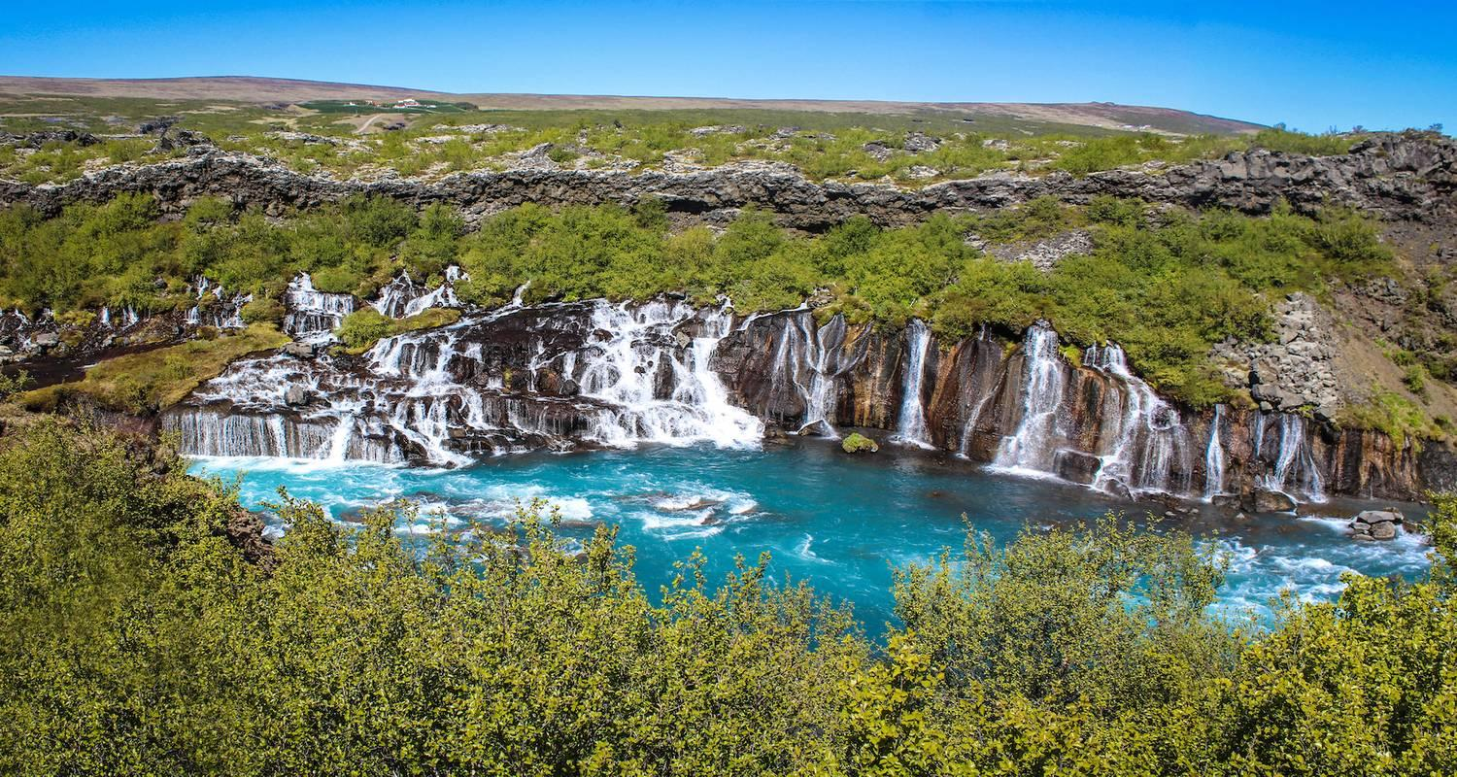

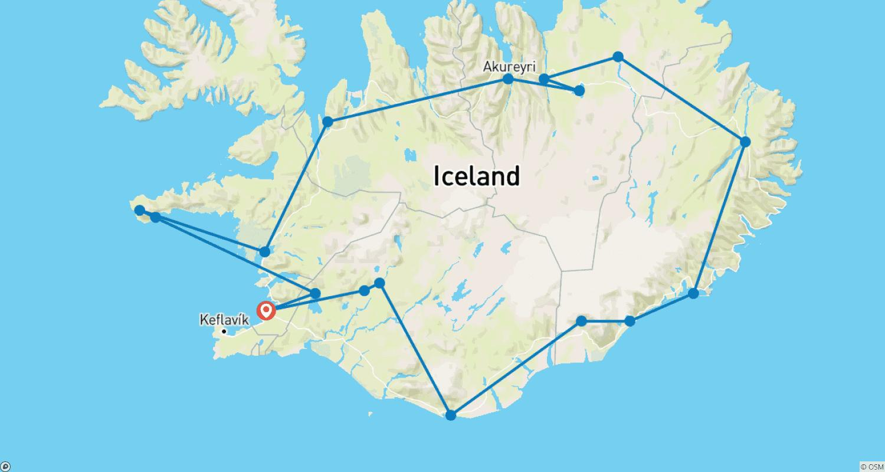

Tour ID: 93945  
Tour Name: 5 Day - Snaefellsnes, South Coast and Northern Lights

Tour destinations: ['Reykjavik', 'Arnarstapi', 'Djupalonssandur', 'Kirkjufell Mountain', 'Reykholt', 'Thingvellir National Park', 'Dover', 'Gullfoss', 'Skogafoss', 'Reynisfjara', 'Vatnajokull National Park', 'Jokulsarlon', 'Skaftafell', 'Fjadrargljufur']

Tour destinations images:

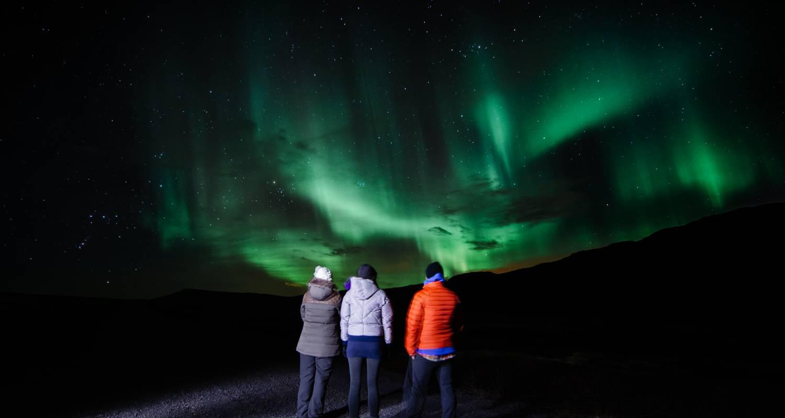

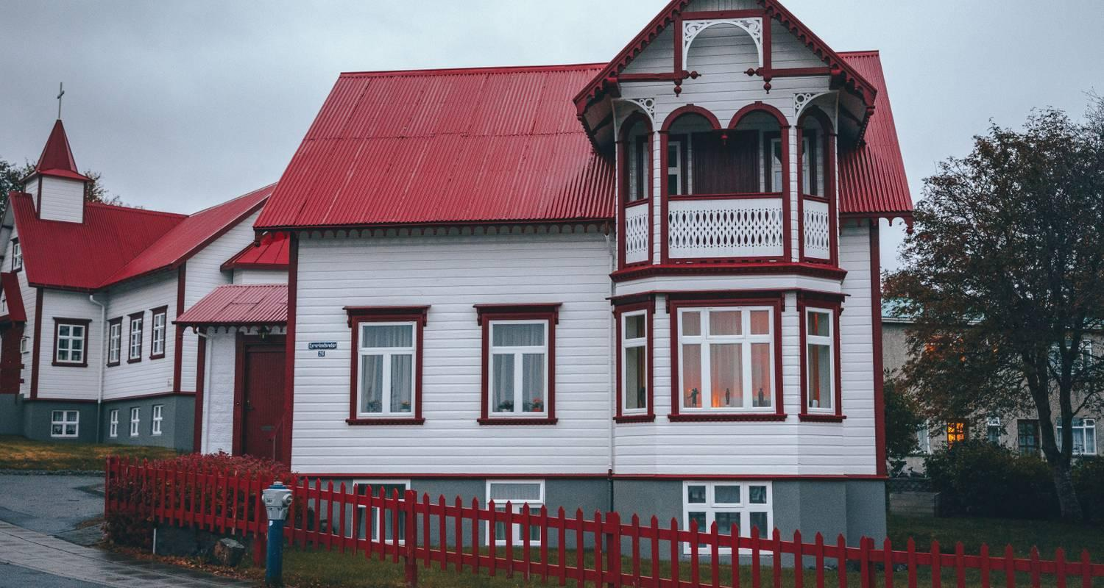

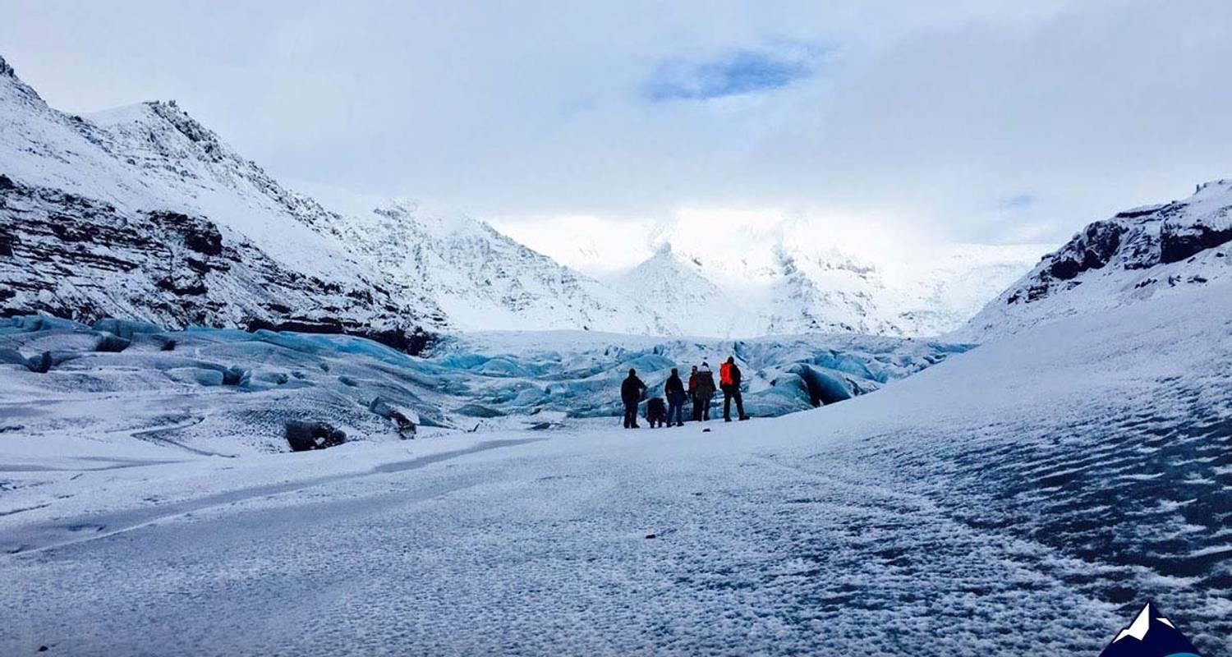

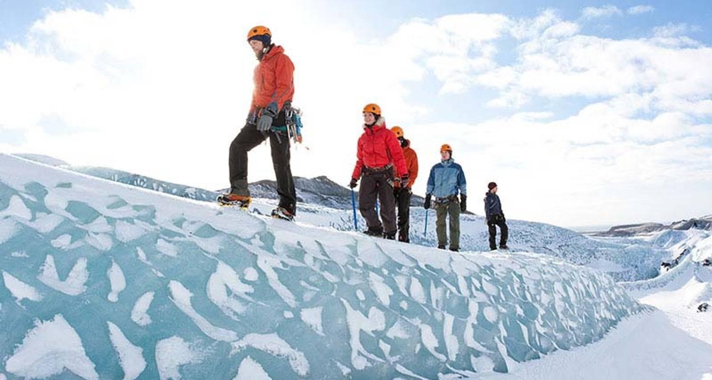

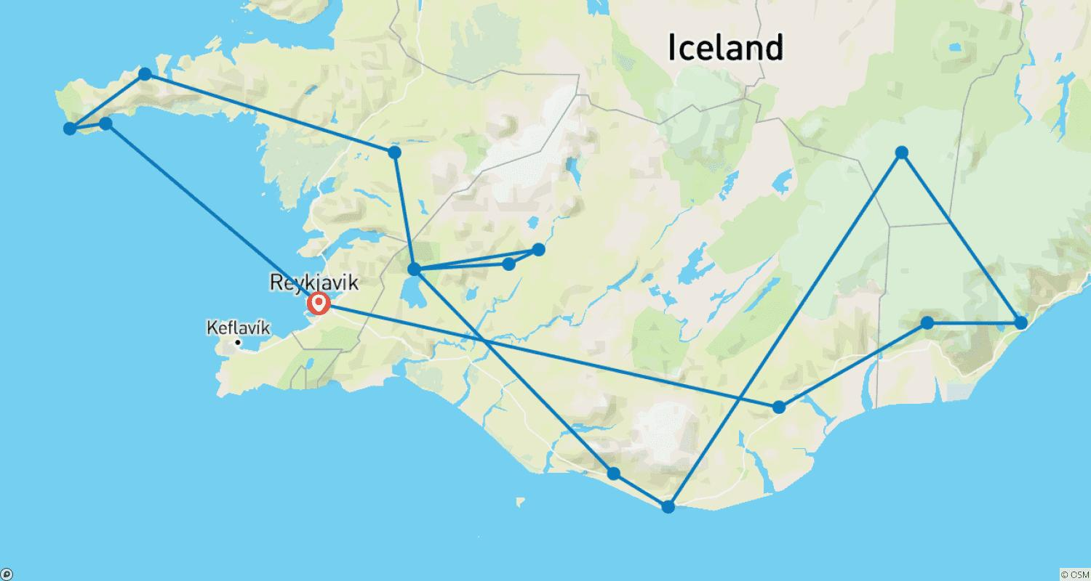

Tour ID: 94146  
Tour Name: 4 Day - Northern Lights, Snæfellsnes & Glacier Lagoon

Tour destinations: ['Reykjavik', 'Reykholt', 'Djupalonssandur', 'Kirkjufell Mountain', 'Skogafoss', 'Reynisfjara', 'Vik', 'Jokulsarlon']

Tour destinations images:

